WEEK 29
REVIEW 5
Part 3 – VIDEO. Task 1, 2, 3
Period 113
I. OBJECTIVES:
1. Knowledge:
- Students will review the words and structures related to the topic On holiday:
2. Competences:
- English competences: Students will be able to talk about “On holiday”.
- Common competences: Students will have the opportunity to develop communication among friends.
3. Qualities:
- Students will be responsible and well-behaved in communicating in the classroom with friends and others.
II. EQUIPMENT AND MATERIALS:
- Basic things: Student’s book, flashcards.
- Advanced things: PPT, projector/interactive whiteboard/laptop/TV.
III. LESSON PROCEDURE:
Warm up (5 minutes)
Aim: warm-up activity to introduce the topic of holiday
Teacher’s activities | Student’s activities
- "Hello students’’  - Ask team names  - Show the puzzle (parallelogram), have Ss guess word’s  letters and what the word is.  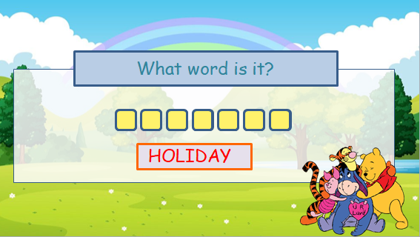  - Click the square box to show the letter, click the rectangle box to show the word.  Review two words by the game: Who jump higher?  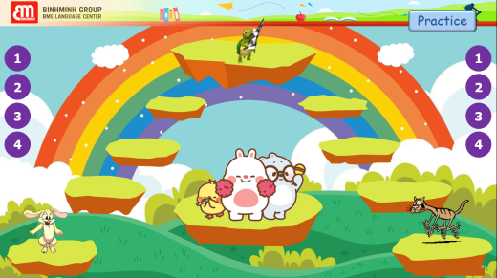  - Divide class into 2 teams and explain game’s rule:  + 2 teams choose numbers to answer questions, if they have the right answer, their teams will jump 1 step.  + The team jumps to the last steps with the Turtle will be the winner. | - Greet teacher  Answer the questions  - Listen carefully the rules.  - Listen to the rule carefully.  - Join the game.  -Look and read.  - Join the game by looking and saying.
Practice (20 minutes)
Aim: Practise words, ask and answer using structure.

Teacher’s activities | Student’s activities
• Watch and understand a video about an interesting country to visit.  • Talk about a favourite trip  1. Circle. What do you like doing on holiday? 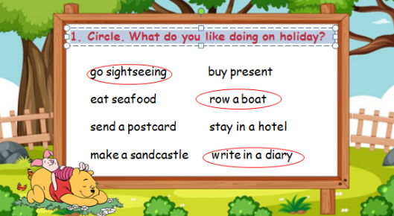  • Tell students to close their books. Go round the class asking them what they like doing on holiday. Write their suggestions on the board.  • Tell students to open their books and look at Activity 1. Review the words with the students.  • Look at the list of activities on the board. How many match the ones in Activity 1?  Task 2: Tick. What can you see in the video?  • Remind students that they are going to watch a video about a cool place to visit.  • Read the instruction to the students. Read through the list of words and make sure students understand the task.  • Tell students to get ready and tick the boxes as they watch the video.  • Play the video all the way through.  • Go through the answers as a class, playing the video again if you need.  3. Read. Tick T for True or F for Fαlse.  • Read out the first statement to the class. Ask students if the Emperor of Japan lives in the Imperial Palace. Elicit Yes. Ask students where the tick should go (T). Put a tick in the ‘T’ box.  • If necessary, play the video again and give students time to complete the activity alone.  • Check the answers with the class | -Look  -Answer  • Open books WW4 and look at Activity 1.  -Look and read the example.  - Look at the list of activities on the board  • Watch a video about a cool place to visit.  • Read the instruction. Read through the list of words  • Get ready to tick the boxes as they watch the video.  -Ask and answer the questions in pairs  - Read out the first statement to the class. - Tick should go (T). Put a tick in the ‘T’ box.  - Practice in front of class
Extra activity (10 minutes)
Aim: Do the exercise to review and remember the words
Teacher’s activities | Student’s activities
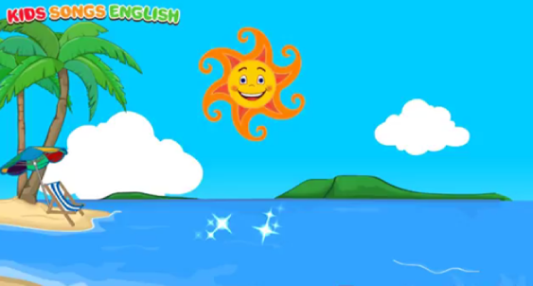  -Ask students to sing and dance. | - Work in groups  - Present.  - Listen.
__________________________________
REVIEW 5
Part 4. Task 1, 2, 3, 4
Period 114
I. OBJECTIVES:
1. Knowledge:
- Students will review the words and structures related to the topic On holiday:
2. Competences:
- English competences: Students will be able to talk about “On holiday”.
- Common competences: Students will have the opportunity to develop communication among friends.
3. Qualities:
- Students will be responsible and well-behaved in communicating in the classroom with friends and others.

II. EQUIPMENT AND MATERIALS:
- Basic things: Student’s book, flashcards.
- Advanced things: PPT, projector/interactive whiteboard/laptop/TV.

III. LESSON PROCEDURE:
Warm up (5 minutes)
Aim: warm-up activity to introduce the topic
Teacher’s activities | Student’s activities
- "Hello students’’  - Ask team names  - Divide class into teams.  - Sing an action song  Review two words by the game: Play game “Building a farm”  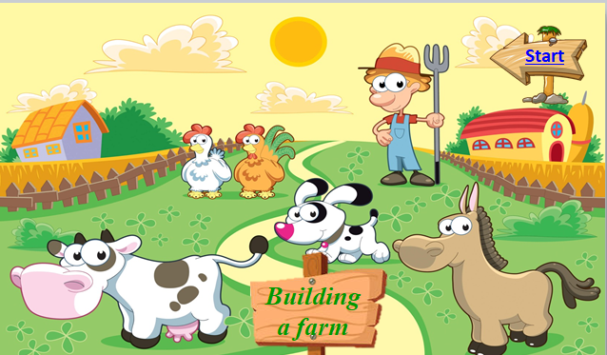  Instruction:  - Ss choose the animal, each animal has a question.  - Ss answer and help farmer collect animals to his farm. | - The Ss greet the teachers chorally.  “Hello teacher ...”  - Say team names.  - Sing and do action.  - Listen the rule carefully.  -Look and read.  -Read  -Identify and read.  - Check with friends and then with teacher and whole class.
Practice (20 minutes)
Aim: Practise words, ask and answer using structure:
Teacher’s activities | Student’s activities
• Ask students to work individually and list activities they like and do not like doing on holiday.  • Tell students to share their lists with their friends and the class.  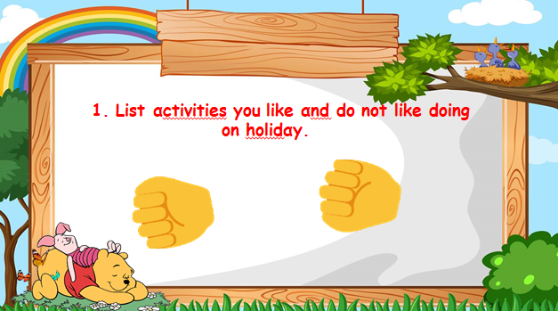  2. Ask and answer questions about a place you would like to visit on holiday.  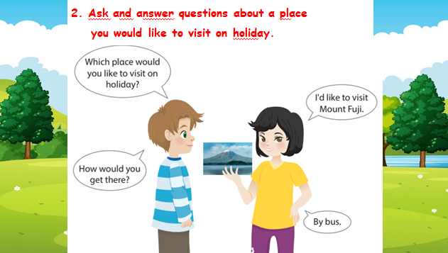  • Read the instruction to the students.  • Invite two students to read the model dialogue.  • Ask students to work into pairs and tell them to talk with their partner about the places they would like to visit.  • Ask some volunteers to act out the dialogue in front of the class.  • Give feedback on some common strengths and  weaknesses. | - Work individually and list activities they like and do not like doing on holiday.  - Share their lists with their friends and the class.  - Check answers  - Read the instruction  - Work in pairs and talk with their partner about the place they would like to visit.  -Ask and answer the questions in pairs  - Check and practice in front of class
Extra activity (10 minutes)
Aim: Do the exercise to review and remember the words
Teacher’s activities | Student’s activities
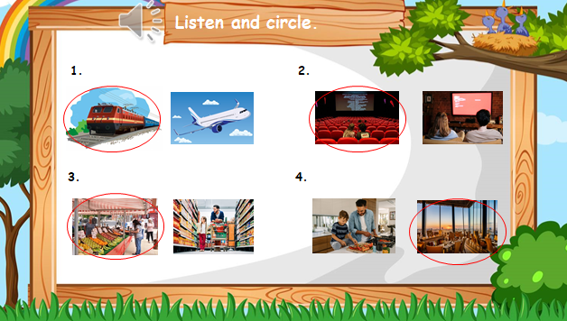  - Encourage students to complete the task. Allow them time to complete it, monitoring and helping when necessary  - Check answers. Ask volunteers to read out their answers.  - Give feedback to them.  -Ask students to sing the goodbye song. | - Work in groups.  - Present.  - Listen.
_______________________________
UNIT 11. BEFORE OUR TIME
Lesson 1. Task 1, 2, 3
Period 115
I. OBJECTIVES:
1. Knowledge: By the end of the lesson, Students will be able to
- Learn and use words related to the topic Some past time: yesterday, last week, last month, last year.
2. Competences:
- English competences: Students have ability to talk about different time in the past.
- Common competences: Students will have the opportunity to develop logical thinking and develop communication among friends.
3. Qualities:
Students will:
- Be aware of different time in the past.
- Be confident and active in communicating with friends and their teacher.
II. EQUIPMENT AND MATERIALS:
- Student’s book, flashcards, track 11.1, track 11.2.
- PowerPoint (PPT) presentation, projector/ laptop, speaker.
III. LESSON PROCEDURE:
Activity 1: Warm-up (5 minutes)
a. Aim: Elicit SS to think about the past time via the photo.
Teacher’s Activities | Students’ Activities
b. Procedure  Warm-up:  Lead in: Photo time!  -T shows the picture about a rock which is drawn a lot of different shapes and gives students some questions: What can you see? Is it in the past or nowadays?  - T calls SS to answer and check their answers.  - T asks SS to look at 4 squares and tick what they can see.  - T introduces some information about this rock. (The photo shows petroglyphs (or rock art) in Nine Mile Canyon, Utah, USA and there are more than 10,000 images there. They were created by the Fremont people between 950–1250 CE, and by the Ute people in the 16th century CE. The images in the photo are by the Fremont people.)  - T introduces that they will learn about “some past time” today.  - Write on the board “Before our time” and introduce the lesson.  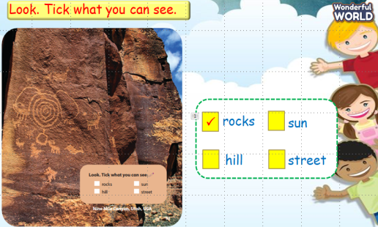 | - Listen and answer the questions.  - Listen to T.  - Answer T.  - Listen to T.  - Listen to T.  .
Activity 2: Presentation (8 minutes)
a. Aim: Present the past time via listening task, introducing the vocab of past time
b. Procedure  Task 1: Listen and point. Repeat. (Track 11.1)  - Use flashcards to introduce the vocabulary of the lesson.  - Say the words for students to repeat in the chorus.  - Say a word for students to repeat then point.  - Check their pronunciation.  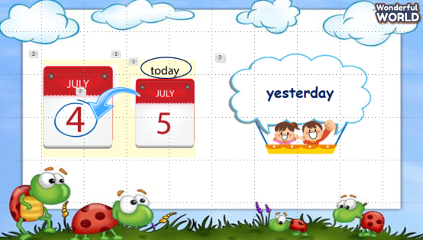  VOCABULARY CHECKING:  Play a game “What’s it?”  - Show a fan with three inside.  - Ask students to read aloud all the words in the fan by clicking “on” on the fan.  - Ask Ss to look at the picture and choose the correct word.  - Ask SS to say the words again.  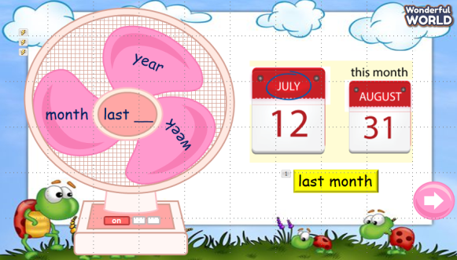  - Play track 11.1 for the students to listen to, point to, and repeat the words in chorus and groups.  - Call SS to read aloud.  - Check and give them feedback.  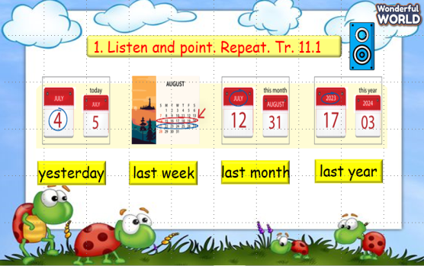 | - Listen and answer T.  - Repeat after the teacher.  - Listen to T.  - Read aloud.  - Look and choose.  - Read aloud.  - Listen and repeat.  - Read aloud.  - Listen to T.
Activity 3: Practice (14 minutes)
- Aims:
- Be able to understand the questions of the listening task related to the past time.
- Be able to answer the questions and circle the correct answers.
- Be able to write the correct time in the past.
- Encourage SS to act out the dialogue in pairs.
b. Procedure  Task 2: Listen and read. Circle. Track 11.2  - Ask SS to look at the picture and answer some questions: Where are they? /How many people can you see? What are they doing? /What can you see in the museum?  - Ask SS to look at the dialogue and identify names of characters in the dialogue.  - Play track 11.2 and let SS listen to the dialogue, then repeat each sentence.  - Ask SS to and read again, then circle the correct answers.  - Let SS read the dialogue by Role-play “Leon and Lisa” to practice the words and the sentences.  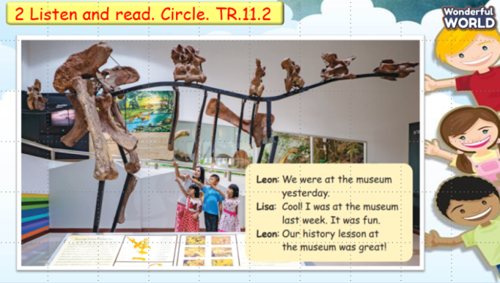  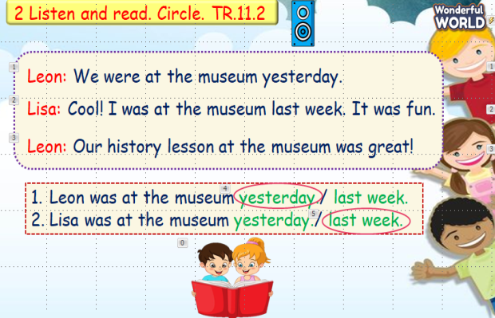  Task 3: Write and say:  - Look at the picture and let SS spell the letters which are missing and say the word.  - Call SS to say aloud in front of the class.  - Check and give them feedback.  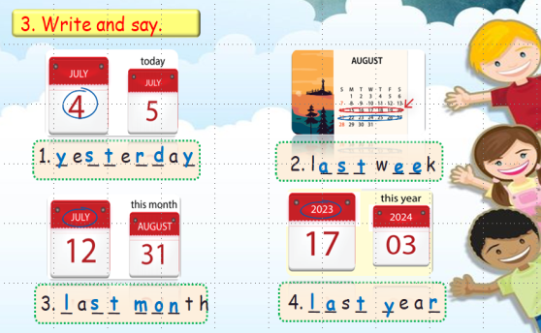 | - Answer T.  - Listen and repeat.  - Read and answer.  - Role play.  - Write the words and say.  - Answer T.  - Say aloud.  - Listen to T.
Activity 4: Production (9 minutes)
a. Aim: Apply vocabulary to play a game about the past time.
b. Procedure  - Work in groups.  - Ask SS to play a small game “Lucky number”.  - Introduce the rule of the game:  (2 teams choose the number and answer, then T can ask SS to make a sentence with this word. Then they move the board with the numbers and letters to choose the points for their team. No point for bomb. Which team has more points will be a winner.)  - Check and give feedback.  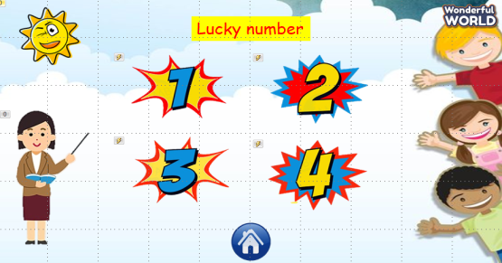  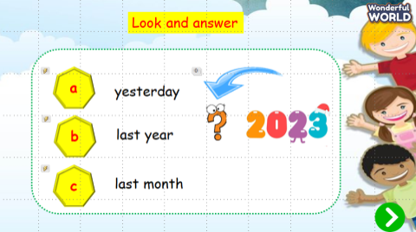  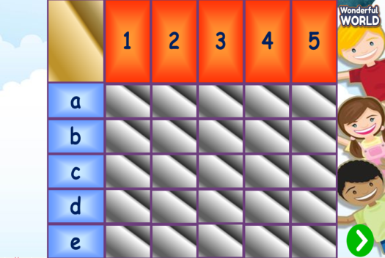 | - Play the game.  - Listen to T.
Activity 5: Assessment (3 minutes)
a. Aims: Consolidate the content of the lesson.
b. Procedure  -Ask sts to do the assessment.  - Check with the class.  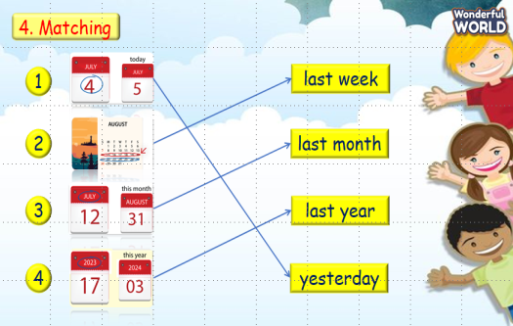 | -Do the assessment.  - Check with the teacher.
_______________________________________

UNIT 11. BEFORE OUR TIME
Lesson 1. Task 4, 5, 6
Period 116
I. OBJECTIVES:
1. Knowledge: By the end of the lesson, Students will be able to
- Review words related to the topic Before our time: yesterday, last week, last month, last year.
- Learn new structures related to where someone was in the past:
Eg: I was at the museum last week.
He was at the shopping centre yesterday.
They were at the restaurant last month.
2. Competences:
- English competences: Students have ability to talk about different time in the past and position of someone in the past.
- Common competences: Students will have the opportunity to develop logical thinking and develop communication among friends.
3. Qualities:
Students will:
- Develop love time in past and where they have ever been.
- Be confident and active in communicating with friends and their teacher.
II. EQUIPMENT AND MATERIALS:
- Student’s book, flashcards, track 11.3.
- PowerPoint (PPT) presentation, projector/ laptop, speaker.
III. LESSON PROCEDURE:

Activity 1: Warm-up (5 minutes)
a. Aim: Review about the past time in the previous lesson.
Teacher’s Activities | Students’ Activities
b. Procedure  Warm-up: Play a small game “Flashcard duck”  The teacher asks SS to play a small game.  T introduces the rule of the game.  (Game: There are 4 students, and each student has a flashcard. T calls a flashcard, and who has this has to raise it over his head. Who is slow or incorrect will be a loser. Who can do the best will be a winner.)  - T asks Ss to repeat time in the past.  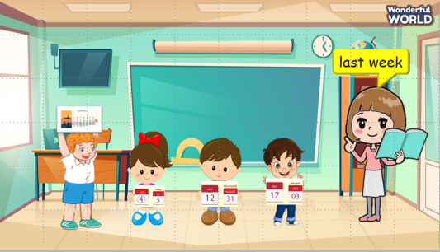  Lead in:  - T introduces that they will review about “time in the past” and learn the structure “where someone was in the past” today.  - Write on the board “Before our time” and introduce the lesson. | - Listen and play the game.  - Repeat.  - Listen to T.
Activity 2: Presentation (8 minutes)
a. Aim: Present how to use “was/were” to talk about places they lived in the past.
b. Procedure  Task 1: Listen and point. Repeat. (Track 11.3)  - Use flashcards to introduce the vocabulary and structure of the lesson.  - Say the words for students to repeat in the chorus.  - Say a word for students to repeat then point.  - Use flashcard “museum” to introduce the structure of the lesson. T helps SS to distinguish how to use “was” and “were” with singular subjects or plural subjects.  - Say the structure for SS to repeat in the chorus.  - Use different flashcards to ask Ss to make sentences.  - Play track 11.3 for the students to listen to, point to, and repeat the words in chorus and groups.  - Check their pronunciation.  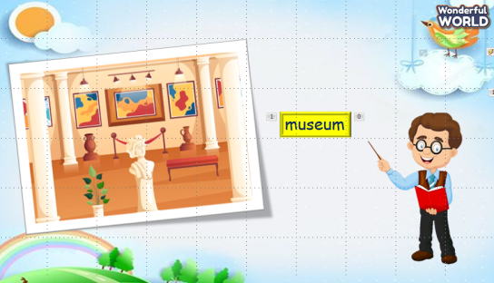  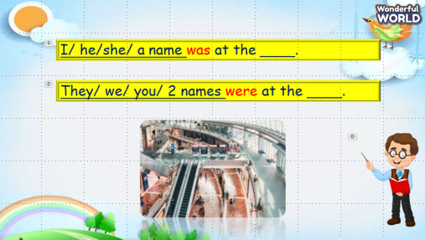  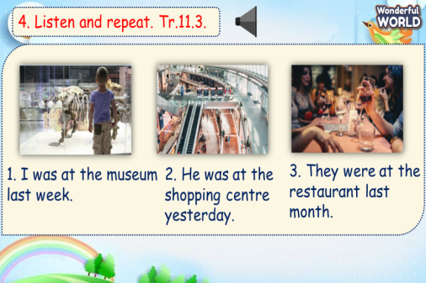 | - Repeat after the teacher.  - Listen to T.  - Make different sentences.  - Listen and repeat.  - Listen to T.
Activity 3: Practice (14 minutes)
a. Aim: Use “was/were” which they have just learnt to complete the sentences about someone’s position in the past time.
b. Procedure  Task 5: Look and say.  - Ask SS to identify names of pictures and words under them.  - Ask SS to look at the board and make a sentence with the words under the picture, then ask SS to work in pairs in 3 min.  - Ask SS to play “Board game”:  (T divides the class into 2 teams. Each team chooses a number and makes a sentence. Then role the dice to move to the goal “Finish”. If they move to the head of snake, they have to move to the tail of snake. Each picture can be used many times.)  - Call some students to read again after the game and give them comments.  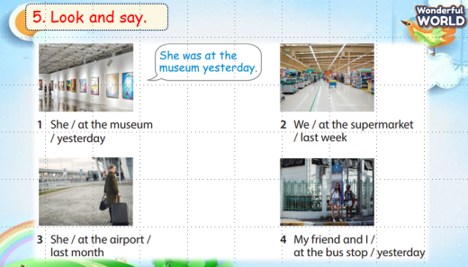  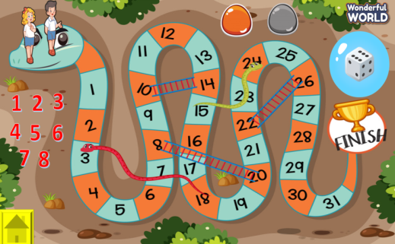 | - Answer T.  - Work in pairs.  - Play the game.  - Listen to T.
Activity 4: Production (9 minutes)
a. Aims:
- Apply to talk about students’ past experience in the past time.
- Encourage SS to work in pairs and present their past experience.
b. Procedure  6. Let’s play.  - Work in pairs.  - Ask SS to look at the board and call a student to make a conversation.  - Ask SS to prepare a pen and paper to draw 2 places where they were in 3 min. Then ask them to work in pairs to ask and answer.  - Call pairs to present in front of the class.  - Check and give feedback.  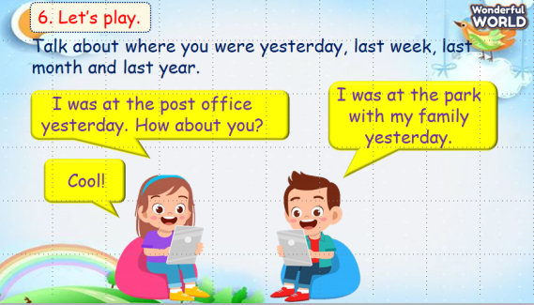 | - Make a conversation.  - Listen to T.  - Draw.  - Work in pairs.  - Present.  - Listen to T.
Activity 5: Assessment (3 minutes)
a. Aims: Consolidate the content of the lesson.
b. Procedure  -Ask sts to do the assessment.  - Check with the class.  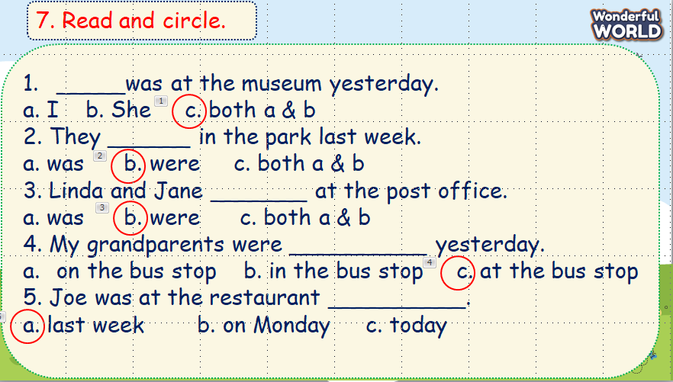 | -Do the assessment.  - Check with the teacher.

_______________________________

