Preparing date: | Teaching date:
15/10/2022 | 9A: 05/11/2022 | 9B: 03/11/2022 | 9C: 04/11/2022 | 9D: 04/11/2022
Period 27
UNIT 4: LIFE IN THE PAST
Lesson 1 - GETTING STARTED: Preserving the past

I. OBJECTIVES: By the end of the lesson, the students will be able to:
1. Knowledge: Read for specific information about children’s pastimes in the past
- Vocabulary: The lexical items related to the topic “The past”.
- Grammar: Structures: - Wish; simple past; used to do sth
2. Skills: Listening, speaking, reading and writing.
3. Attitude: - Ss have a positive attitude towards what they have learnt; understand and actively respond to relevant matters or situations.
4. Competencies:
- Form and/or improve such competencies as collaboration, teamwork, communication, presentation, problem solving, assessment, etc.
II. PREPARATIONS:
Teacher: Projector, textbook, pictures, lesson plan.
Students: Textbooks, notebooks …
III. ANTICIPATED PROBLEMS AND SOLUTIONS:
- Students may not be familiar with many difficult past activities.
* Proposed solutions: The teacher should prepare the lesson carefully and give the students clear instructions.
IV. PROCEDURE:
Teacher’s and Student’s activities | Contents
I. WARM UP (IW/5’)  T prepares some photos or magazine cut-outs about some common activities in the past ( 30 years ago) and at the present. Show them to Ss and let them group the pictures into the past or present. Ask for an explanation of the groupings.  - Ss answer the question as a class | 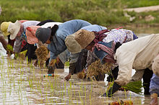  UNIT 4:  Lesson 1 - GETTING STARTED
II. NEW LESSON  1. Set the scene (IW/2’)  Ask Ss to look at the title of the conversation and the picture. Ask them some questions:  • What do you think the people in the conversation are talking about?  • How do you understand the title ‘Preserving the past’?  Ss answer the questions as a class.  2. Vocabulary (IW/5’)  - Teacher use different techniques to teach vocabulary (situation, realia)  - Follow the seven steps of teaching vocabulary  * Checking vocab: Ordering | I. VOCABULARY  - technological (adj): thuộc công nghệ  - wealthy (adj): giàu sang, giàu có  - gap(n):sự khác biệt, khoảng trống  - loudspeaker(n):loa  - science fiction(n):khoa học viễn tưởng  - mobile movie team(n):đoàn chiếu phim lưu động  - funaral (n): đám tang, lễ tang
III. LISTEN AND READ  TASK 1:  a) Read the conversation again and answer the questions (IW, PW/5’)  - Ss work independently. Encourage them to answer the questions without looking back at the conversation. Then allow Ss to share answers. Check their answers as a class.  b) Match the expressions (1 - 4) from the conversation with their meanings. Can you add some more expressions with the same meaning? (IW,PW/5’)  - Asks Ss to find the expressions in the conversation and rea the context where they appear to make sure that they understand the meanongs of the expressions correctly.  - Ss then do the matching.  - T Corrects the answers as a class. Ask Ss if they can think of some more expressions with the same meaning.  - Individual work, and then share the answers with a partner.  c) Choose suitable expressions from 1b to the complete the conversations (PW/6’)  - Have Ss work in pairs to find the most suitable response to each item.  - SS can then exchange their anwers.  - T check as a class and explains the answers where necessary.  TASK 2: Use the words/phrases in the box to complete the sentences. (PW/5’)  - T runs through the given words, make sure Ss understand the meaning of the words in the box. - T can ask them to give some examples to show that they understand the phrase “ technology changes”.  - Ss then work independently to complete the sentences. Have them share their anwers in pairs  - Then elicit the anwers from the whole class. | I. LISTEN AND READ  1a. Read the conversation again and answer the questions:  Answers:  1. Fathers make kites for sons.  2. Once every two months.  3. They used to come early, trying to get a place near the screen.  4. Only wealthy households.  5. Yes, he does. He said: “Sometimes I wish I could go back to that time.”  1b. Match the expressions. Can you add some more expressions with the same meaning?  Key:  - How cool = C 3. Sure = A  - Wow ... = D 4. I wish … = B  1c. Choose suitable expressions from 1b to the complete the conversations.  KEY:  - Sure  - I can’t imagine that.  - How cool!  - I wish I could go back to that time.  How cool!  5. I can’t imagine that  2. Use the words/phrases in the box to complete the sentences.  KEY  - Loud speaker  - Traditions  - Generations  - technological changes  - events
III. FURTHER PRACTICE  TASK 3: In group, brainstorm some of the past events and practice in your area. Make a list and present them to the class (GW/5’)  - Have Ss work in small groups to come up with as many past events and practices in their areas as possible.  - Give the groups a time limit, for example, five minutes.  - Have them present the list they have made to the class. As a whole class, decide if these practices were specific to their region or neighborhood or were also practiced elsewhere | 3. In group, brainstorm some of the past events and practice in your area. Make a list and present them to the class  Example: Women in Hue used to go swimming at the beach fully clothed, to wear palm leaf conical hats, to wear the traditional long dress whenever they went out, to stay at home as housewives, ...
IV. WRAPPING UP (GW/5’)  To give Ss chance to think of or to get more knowledge about traditions  * Game:  Customs and Traditions experts  - Tell Ss-groups to write the activities and make up sentences with used to.  Group work | - Play the game  *Game Ss - groups write the activities on the posters for exhibition around the class
V. HOMEWORK (2’)  T elicits Ss to do homework  - Write down. | - read the dialogue  - Do ex in work book
Feedback:
...........................................................................................................................................................
...........................................................................................................................................................
...........................................................................................................................................................
...........................................................................................................................................................

Preparing date: | Teaching date:
15/10/2022 | 9A: 08/11/2022 | 9B: 07/11/2022 | 9C: 08/11/2022 | 9D: 08/11/2022
Period 28
UNIT 4: LIFE IN THE PAST
Lesson 2: CLOSER LOOK 1 (Activities 1- 6; page 42)

I. OBJECTIVES: By the end of the lesson, the students will be able to:
1. Knowledge: Focus on the stressed auxiliaries; use the lexical items related to the topic life in the past.
- Vocabulary: The lexical items related to the topic “The past”.
- Grammar: Structures: pastime activities in the past; using “used to + V” to express habitual activities.
2. Skills: Listening, speaking, reading and writing.
3. Attitude: - Ss have a positive attitude towards what they have learnt; understand and actively respond to relevant matters or situations.
4. Competencies:
- Form and/or improve such competencies as collaboration, teamwork, communication, presentation, problem solving, assessment, etc.
II. PREPARATIONS:
Teacher: Projector, textbook, pictures, lesson plan.
Students: Textbooks, notebooks …
III. ANTICIPATED PROBLEMS AND SOLUTIONS:
- To check comprehension, T can ask Ss to mime activities to ensure everyone has a thorough understanding of the phrases.
- Ss might have difficulty with the meaning of ‘act out stories’, ‘go bare-footed’, and ‘dance to drum music’.
* Proposed solutions: The teacher should prepare the lesson carefully and give the students clear instructions
IV. PROCEDURE:
Teacher’s and Student’s activities | Contents
I. WARM UP (5’)  Reviewing the activities in the past they have learnt as well as warming up the class and leading in the new lesson | the past events and practices in your area  the past events  UNIT 4: LIFE IN THE PAST  Lesson 2: CLOSER LOOK 1  the past events and practices in your area
II. VOCABULARY  * New words (IW/7’)  To give Ss a chance to practice more about the pastimes activities in  - Ask the students to repeat the words and phrases, guess the meaning and write down.  - Ss practice reading the vocabulary in choral, individually  - Write down  TASK 1: Matching a verb in A with a word/phrase in B. (GW/5’)  - Divide the class into two teams  - Ss might have difficulty with the meaning of ‘act out stories’, ‘go bare-footed’, and ‘dance to drum music’.  * To check comprehension,  - T can ask Ss to mime activities to ensure everyone has a thorough understanding of the phrases.  - Work in two teams.  - Ss from each team in turns say match a verb in column A with word or phrase in B  TASK 2: Use the newly- formed phrases in 1 with the verbs in their correct forms to complete the sentences.(IW/5’)  - T asks ss to choose the correct answer for each sentence first.  - Ss read the sentence carefully to determine the form and the sentence carefully to determine the form and the tense of verb.  - Check the answers as a class.  TASK 3: Choose a word/ phrase from the  box to complete the sentences (IW/5’)  - T asks Ss to work individually to complete the sentences  - Ss are asked to exchange their answers with their partners.  - Check as a class. Now ask for volunteers, or select SS, to make new sentences using these words and phrases.  - T corrects and gives feedback.  TASK 4: Complete the sentences with the right form of the words below (PW/5’)  Ask SS to cover the remember! Box and elicit the definitions of possible  - Ss work in pairs to do this TASK  - Ss stick their paper on the board then read and comment on each other’s sentences.  - T checks to make sure Ss use the correct verbs/verb phrase. | 1 * New words  1. Keep a diary: giữ nhật ký  2. Go bare footed: đi chân không  3. Tug and war: chơi kéo co  4. Seniority: cao tuổi, cao niên  5. Illiterate: người mù chữ  6. street vendors: người bán hàng rong  2. VOCABULARY  1. Match a verb in A with a word/phrase in B.  1f 2. g 3. b 4.a  5. c 6. e 7.h 8.d  2. Use the newly- formed phrases in 1 with the verbs in their correct forms to complete the sentences.  1. Kept diary  2 entertain themselves  3. Preserve our traditions  4. Use your imagination.  5. acting out stories  6. Collect the post  7. Going bare- footed  8. Dance to drum music.  3. Choose a word/ phrase from the  box to complete the sentences  1. seniority  2. Illiterate  3. Street vendors  4. strict rules  5. Physical  6. Face to face  4. Complete the sentences with the right form of the words below.  1. Habit 2. Behavior 3. Tradition  4. habit 5. practice 6. behavior
PRONUNCIATION  TASK 5: Listen and underline the auxiliary verbs which are stressed. Then practice saying the sentences (IW/5’)  To help Students to focus on stress auxiliary verbs in sentences  - Ask the students to listen and underline the auxiliary verbs which are stressed.  - Ask the students to repeat the sentences in chorus, then say the sentences individually.  Note: This exercise focuses only on stressed/unstressed auxiliaries. Sentences 1 and 2 contain no stressed auxiliaries.  TASK 6: Underline an auxiliary if it is stressed. Then listen, check, and repeat the sentences. (IW/4’)  - Have Ss work individually to stress the auxiliaries. Ask them to refer to the REMEMBER! box as they do the exercise. Then play the recording. Ss listen, check, and say the sentences. Call on some Ss to say the sentences individually.  - Listen, check, and say the sentences. - Some Ss say the sentences individually. | Exercise 5. Listen and underline the auxiliary verbs which are stressed. Then practice saying the sentences.  1. Life will be improved in those remote areas.  2. They can see the rain coming in from the west.  3. You did make me laugh!  4. He hasn’t handed in his assignment.  5. I don’t like the idea of going there at night.  6. Sam doesn’t like fast food but I do  Exercise 6. Underline an auxiliary if it is stressed. Then listen, check, and repeat the sentences.  1. - The men in my village used to catch fi sh with a spear.  - Could you do that?  - No, I couldn’t.  2. I have told you many times not to leave the door open.  3. We’re going to visit Hawick, a historical village.  4. - You aren’t going to the party? Is it because you can’t dance?  - I can dance. Look!  5. - I hope she doesn’t do any damage to the car.  - Don’t worry. She does know how to drive
WRAPPING UP (3’)  To give a practice on using USED TO +V  - Ask students to complete the sentences using the given words  Tradition/ habit /behavior /practice  KEY:  1. habit  2. behavior  3. tradition  4. habit  5. practice | Complete the sentences with the right form of the words below.  Tradition/ habit /behavior /practice  1. It’s never easy to break a bad __.  2. His bold ______ shocked everybody present.  3. It runs as a ______ in Viet Nam that elderly grandparents and parents are taken care of by their children until they die.  4. It was his ______ to take a nap after lunch.  5. Using blackboards and chalk as the only teaching aid is still a common ______ in most developing countries.
HOME ASSIGNMENT (1’)  T elicits Ss to do homework | - Use the words in exercise 1 to make up sentences using USED TO
Feedback:
...........................................................................................................................................................
...........................................................................................................................................................
...........................................................................................................................................................
...........................................................................................................................................................

Preparing date: | Teaching date:
15/10/2022 | 9A: 11/11/2022 | 9B: 08/11/2022 | 9C: 10/11/2022 | 9D: 10/11/2022

Period 29 UNIT 4: LIFE IN THE PAST
Lesson 3: CLOSER LOOK 2 (Activities 1 - 5; page 43, 44)

I. OBJECTIVES: By the end of the lesson, the students will be able to:
1. Knowledge: Know to use “used to do sth/ didn’t use to do sth
How to make a wish for the present/future or for something happening right at that moment.
- Vocabulary: The lexical items related to the topic “The past”.
- Grammar: Structures: pastime activities in the past; using “used to + V” to express habitual activities.
2. Skills: Listening, speaking, reading and writing.
3. Attitude: - Ss have a positive attitude towards what they have learnt; understand and actively respond to relevant matters or situations.
4. Competencies:
- Form and/or improve such competencies as collaboration, teamwork, communication, presentation, problem solving, assessment, etc.
II. PREPARATIONS:
Teacher: Projector, textbook, pictures, lesson plan.
Students: Textbooks, notebooks …
III. ANTICIPATED PROBLEMS AND SOLUTIONS:
- Students may have difficulty in using used to and Wish.
* Proposed solutions: The teacher should prepare the lesson carefully and give the students clear instructions
IV. PROCEDURE:
Teacher’s and Student’s activities | Contents
I. WARM UP  TASK 1: Read the conversation from getting started and underline the examples of used to + infinitive. Then tick (V) the correct answer. (IW/5’)  T asks ss underline the sentences containing used to/ didn’t use to + inf in the GETTING STARTED. Choose the correct answer  A, B, or C  T elicits ss’ answers and then confirms the correct ones and give the rule on the board | UNIT 4: LIFE IN THE PAST  Lesson 3: CLOSER LOOK 2
II. GRAMMAR  1. “USED TO” and how to use them (IW/5’)  T elicits the use of “USED TO” from the ex  - T give their ideas then copy down  TASK 2: Use used to or didn’t use to with the verbs from the box to complete the sentences (PW/6’)  Ask the students to do exercise  - The whole class.  - Ss write the answers on.  - Others give  2. Grammar 2: WISH SENTENCE  TASK 3: Read the GETTING STARTED again and look for sentences containing wish (IW/7’)  - T asks ss to underline the main verbs in the sentences and answer the questions.  - Elicit usage and form from the students.  T asks ss to read the LOOK OUT! box  on page 44 and copy down the form  - Show the form on the screen or write on board.  TASK 4: Tick () if the sentence is correct. If the sentence is not correct, underline the mistake and correct it. (IW/5’)  - Have Ss do this exercise individually. They may refer to the rule on the board. T checks the answers as a class  TASK 5: Make up wishes from the prompts (IW/7’)  - Ask students to make up wishes from prompts.  - Have Ss work in pairs.  - TWC check and give feedback.  - Pair work  - Then Ss write on the board. Others give feedback. | I. Grammar 1  1. “USED TO” and how to use them  We use used to and didn’t use to + infinitive to talk about ______.  - an TASK that happened only once in the past  - an TASK that repeatedly happened in the past  - an TASK that started in the past and continues to the present  2. Use used to or didn’t use to with the verbs from the box to complete the sentences.  1. Used to be  2. Didn’t use to transport.  3. Used to dye  4. Used to kill  5. Used to pull out  6. didn’t use to spend  II. Grammar 2: WISH SENTENCE  1. FORM:  * Wish + Simple Past.  * Wish + Past Continuous.  * Wish + Past Perfect. We use “wish” + past perfect to express regret.  * Wish + would.  We use “wish” + past continuous to express that we want to be doing a different TASK in the present (or the future).  2. Tick () if the sentence is correct. If the sentence is not correct, underline the mistake and correct it  1  4  2. will → would  3. can → could  5. don’t → didn’t  6. is → was/were  5. Make up wishes from the prompts  1. I wish we could communicate with animals.  2. I wish no child was/were suffering from hunger.  3. I wish I was/were playing on the beach.  4. I wish there was/were/would be no more family violence in the world.  5. I wish I was/were going bushwalking with my friends.  6. I wish there were four seasons in my area.
WRAPPING UP (8’)  - Ask students to work in group of four to make sentences with used to and wish.  Ex: In the past we didn’t use to have computers. I wish in the past we had computers.  T monitors the class and help students if they need  some of : they may ask some vocabulary | Ex: In the past we didn’t use to have computers. I wish in the past we had computers.
HOME ASSIGNMENT (2’)  - T elicits Ss to do homework | - Write 5 sentences using USED TO and 5 sentences with WISH
Feedback:
...........................................................................................................................................................
...........................................................................................................................................................
...........................................................................................................................................................
...........................................................................................................................................................

Preparing date: | Teaching date:
15/10/2022 | 9A: 12/11/2022 | 9B: 10/11/2022 | 9C: 11/11/2022 | 9D: 11/11/2022

Period 30 UNIT 4: LIFE IN THE PAST
Lesson 4: COMMUNICATION (Activities 1- 5; page 45)

I. OBJECTIVES: By the end of the lesson, the students will be able to:
1. Knowledge: - understand of what life was like for these people.
- use their critical thinking skills to find explanations some information from
the stories.
- Create their own stories about life in the past in Vietnam.
- Vocabulary: The lexical items related to the topic “The past”.
- Grammar: Structures: pastime activities in the past; using “used to + V” to express habitual activities.
2. Skills: Listening, speaking, reading and writing.
3. Attitude: - Ss have a positive attitude towards what they have learnt; understand and actively respond to relevant matters or situations.
4. Competencies:
- Form and/or improve such competencies as collaboration, teamwork, communication, presentation, problem solving, assessment, etc.
II. PREPARATIONS:
Teacher: Projector, textbook, pictures, lesson plan.
Students: Textbooks, notebooks …
III. ANTICIPATED PROBLEMS AND SOLUTIONS:
- Students may not know well about the past. Teacher should help
* Proposed solutions: The teacher should prepare the lesson carefully and give the students clear instructions.
IV. PROCEDURE:
Teacher’s and Student’s activities | Contents
I. WARM UP (GW/5’)  - T shows ss 2 pics: before/ after (same place)  - Ss look at the pictures and discuss the differences between the past and present  - T encourages ss to give extra vocabulary and use USED TO  - Ss discuss the differences between the past and present |   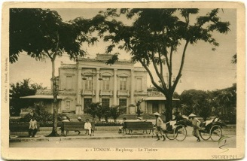  UNIT 4: LIFE IN THE PAST  Lesson 4: COMMUNICATION
II. PRESENTATION  To teach students some words relating to the topic and engage Students in the topic of the landmarks  - Ask the students to practice reading the vocabulary, and then copy down.  TASK 1:  a)Look at the introduction to the competition that was launched on the 4Teen website. Discuss the questions (GW/5’)  - T can start this session by writing “ looking back” on the board and leading SS through the discussion of the questions. Encourage Ss to give any or all ideas, there are no wrong answer at this stage.  - Ss work in small group to give their ideas  - T collect the ideas (There are no wrong answers at this stage) | I. Extra vocabulary: ( P.45)  - Igloo (n): lều tuyết  - domed: (n)mái vòm  - Artic: (adj): thuộc về bắc cực  - dogsleds : xe đi trên tuyết do chó kéo  - Remove area (n): vung sâu , vùng xa
II. PRACTICE  TASK 1b) Read the stories and see if your answer are correct (PW/5’)  - Ask the students to read the passage to find out the answers.  - Answer the questions Then refer to their answers in 1a and see if their guesses are correct.  - T asks for the key  - Others ss give feed back  - T confirms the answer  TASK 2: Read the stories and find the words which mean: (IW/7’)  - Have Ss read the definitions and look for the words in each story.  - Ss do this individually.  - T asks for the key  - Others ss give feed back  - T confirms the answer  TASK 4: Which responses relate to which story (PW/7’)  - Ss work in groups to use their critical thinking skills to find explanations for the questions.  - Ask them to underline the key words in the responds which help them do the matching.  - T gives acts as a facilitator. | II. Read  1b: Read the stories and see if your answer are correct  Suggested answer  1. It collects stories about the past to help people understand more about life in that time.  2. I think the elderly/ everybody sent in the stories to the competition  3. The first story is about work of a postman in a remote area and the second one is about life and traditions in Baffin Island long time ago.  2. Read the stories and find the words which mean: KEY:  - illiterate  - pass on  - treat ( some one)  - block  - survive  - dogsled.  3. Which responses relate to which story  - Story 1: 2, 4  - Story 2: 1, 3, 5
III. FURTHER PRACTICE (DISCUSSION)  - T asks Students work in groups of four to discuss the questions  TASK 3: What do YOU think?  Work in groups. Discuss the questions. (GW/7’)  - Ss work in groups, use their critical thinking skills to fi nd explanations for the questions. Ss will  consequently gain a deeper understanding of what life was like for these people.  - T acts as a facilitator, encourage them to use their imagination and background knowledge to explain some information from the stories.  - Ss then share their opinions with the class. | 4. What do YOU think?  Work in groups. Discuss the questions.  Suggested answers:  1. It was difficult to reach the villagers on the mountain./There were no other means of transport  available.  2. There was no school in the villages./The nearest school might be too far away.  3. There were no other materials available in that deserted land./There were no easy means to transport materials from other places to the island.  4. It was impossible to build a big house with several rooms in the ice and snow./People felt safer living.
WRAPPING UP  TASK 5 : Work in groups. Work out a story for the Looking Back competition (GW/7’)  Helping Students to sum up whole knowledge from speaking  - Ss work in small groups and work out a story of their own. Make sure Ss include the necessary information in the story as suggested in the task.  - Each group the presents the story to the class. The rest of the class can ask questions about topic.  - T acts as a facilitator, encourage them to use their imagination | 5. Work in groups. Work out a story for the Looking Back competition.  Decide:  - What aspect of life you want to talk about  - How it was practiced  - If you wish it would still be practiced  Example:  My father grew up in the countryside near by Hanoi. He used to play with the peers in the village  Back to that time, there was no computer or smart phones ; and toys were really rare and luxurious. However, my father said he had had a quite memorable childhood with his friends. They created physical games to entertain themselves. Traditional games were really popular. They played with marbles, plastic band, leaves and flowers instead of stuffed animals, dolls or miniature vehicle. At that time, there were also more outdoor space for children than at present. They could easily find a place for going fishing or flying a kite. I find the story about my father’s childhood really interesting and amazing  I wish I could do things like him at that time with my friends now. That must be wonderful!
HOME ASSIGNMENT (3’)  T elicits Ss to do homework | - Do ex in work book

Feedback:
...........................................................................................................................................................
...........................................................................................................................................................
...........................................................................................................................................................
...........................................................................................................................................................

Preparing date: | Teaching date:
15/10/2022 | 9A: 15 /11/2022 | 9B: 14/11/2022 | 9C: 15 /11/2022 | 9D: 15 /11/2022

Period 31
CORRECT TEST N01

I. OBJECTIVES: By the end of the lesson:
1. Knowledge: Ss can do self- assessment the knowledge they have done in the test, include: pronunciation, vocabulary and grammar they have learnt from unit1-2-3.
- Vocabulary:
- Grammar: The present simple; Present continuous, Present continuous for future.....
2. Skills: listening, reading, writing
3. Attitude: Ss review the knowledge from Unit 1- 3 and do self- assessment
4. Competencies:
- Form and/or improve such competencies as: collaboration, teamwork, communication, presentation, problem-solving, assessment, etc.
II. PREPARATIONS:
Teacher: tests
Students: Notebooks
III. PROCEDURE:
Answer key
C/ ANSWER KEY
A - LISTENING
I. Listen to the conversation and choose the best answer to the questions.
(0,2 for each correct answer - 6 x 0,2 = 1,2)
1. D. Italy 2. D. 42 3. B. Long Island
4. B. watch TV 5. C. to the movies 6. B. 30
II. Listen and decide which sentence is true (T) or false (F).
(0,2 for each correct answer - 6 x 0,2 = 1,2)
1. T 2. F 3. F 4. F 5. T 6. T
B. LANGUAGE FOCUS
I. Choose the word whose underlined part pronounced differently from the others (0.4pts)
(0,2 for each correct answer / 2 x 0,2 = 0.4)
1. C. embarrassed 2. C. decision
II. Choose the word that has different stress from others.(0.4pts)
(0,2 for each correct answer / 2 x 0,2 = 0.4)
1. D. embroider 2. D. fashionable
III-Choose the best answer A, B, C or D to complete the sentences. (1.4pts)
(0,2 for each correct answer / 7 x 0,2 = 1,4)
1. D. because 2. C. off 3. A. pottery 4. A. Sounds great.
5. C. been passed down 6. A. physical 7. B. put themselves 8. C. happy
IV. Write the correct form of the words in brackets.
(0,2 for each correct answer / 2 x 0,2 = 0.4)
1. has asked 2. affordable
C. READING
I. Read the following passage and mark the letter A, B, C, or D on your answer sheet to indicate the correct word or phrase that best fits each of the numbered blanks
(0,2 for each correct answer - 6 x 0,2 = 1,2)
1. by 2. Pottery 3. Started 3. Took over 4. Well-known 6. Make
II. Read the following passage and mark the letter A, B, C, or D on your answer sheet to indicate the correct answer to each of the questions
(0,2 for each correct answer - 6 x 0,2 = 1,2)
1. C 2. A 3. D 4. C 5. A 6. D
D. WRITING
I. Mark the letter A, B, C or D on your answer sheet to indicate the underlined part that needs (0,2 for each correct answer /2 x 0,2 = 0,4)
1. A. depressed 2. C- had gone
II. Rewrite sentences without changing meaning with the words in brackets.
(0,2 for each correct answer /3 x 0,2 = 0,6)
They’re not sure how they should operate the new system. (TO)
1. They’re not sure how to operate the new system
2. We decided to take rooms in Longwood House EVEN THOUGH we knew we could not afford the rent.
3. I’m LOOKING FORWARD TO the holiday.
III. Make sentences with the word given (1pt)
(0,2 for each correct answer /5 x 0,2 = 1,0)
- I have never read such a romantic story like this before
- She spends most of time surfing the net for information about the next trip
- He said that he would send us a postcard following day.
- She wondered whether to tell her best friend what she had thought.
- Yesterday my mother picked me up late.
IV. Rearrange the words to make meaningful sentence
(0,2 for each correct answer /3 x 0,2 = 0,6)
1. Could you tell me who I should ask for advice?
2. He thinks no language in the world is more difficult than Chinese.
3. Many of those old buildings will soon be pulled down.
B. FEED-BACK:
- Listening: ..................................................................................................................................
- Phonetics: ..................................................................................................................................
- Language focus: ..................................................................................................................................
- Reading: ..................................................................................................................................
- Writing: ..................................................................................................................................
C. RESULTS:

Class | No of ss | 0-2 | 3-4 | % | 5-6 | 7-8 | 9-10 | %
9A | 41
9B | 39
9C | 40
9D | 45

- Listening: Many students in class 9C did the listening tasks well. But students in class 8A, B need to improve their listening skill.
- Phonetics: Ss need to learn by heart vocabulary and do more exercises to improve the phonetics (word stress placements, pronunciation of ending “s, es” in words).
- Language focus: Weak students don’t remember the vocabulary and the present continuous tense. Many didn’t supply the correct tense of verbs and made mistakes with “like + Ving/ would like + to V”.
- Reading: Students in class 9A, B did not answer the questions well. Some students only copied the sentences in the text but did not read the questions carefully.
- Writing: Students made mistakes they haven’t remembered structure, especially Comparative form and reported speech

Preparing date: | Teaching date:
15/10/2022 | 9A: 18 /11/2022 | 9B: 5 /11/2022 | 9C:7 /11/2022 | 9D:17 /11/2022
Period 32
UNIT 4: LIFE IN THE PAST
LESSON 5: SKILLS 1 (page 46)

I. OBJECTIVES: By the end of the lesson, the students will be able to:
1. Knowledge: to know more about some traditional games.
- Read for specific information how children in the past spent their pastime.
- Talk about their own past time.
- Compare the two ways of spending free time in the past and nowadays then withdraw which habit would you like to preserve.
- Vocabulary: The lexical items related to the topic “The past”.
- Grammar: Structures: pastime activities in the past; using “used to + V” to express habitual activities.
2. Skills: Listening, speaking, reading and writing.
3. Attitude: - Ss have a positive attitude towards what they have learnt; understand and actively respond to relevant matters or situations.
4. Competencies:
- Form and/or improve such competencies as collaboration, teamwork, communication, presentation, problem solving, assessment, etc.
II. PREPARATIONS:
Teacher: Projector, textbook, pictures, lesson plan.
Students: Textbooks, notebooks …
III. ANTICIPATED PROBLEMS AND SOLUTIONS:
Students may not know how to play some traditional games. Teacher should explain them the rule the way it was played.
* Proposed solutions: Teacher should prepare the lesson carefully and give the Ss clear instructions
IV. PROCEDURE:
Teacher’s and Student’s activities | Contents
WARM UP (PW/5’)  Helping Ss to know some children traditional gamesin the past.  T asks Ss to match the pictures with the names of the games  - Pair work  - Give the answers  1. Bamboo jacks: đánh chuyền,chắt chuyền (10 que tre và 1 quả bóng,..)  2. Blind man’s bluff: bịt mắt bắt dê  3. Hopping games : nhảy lò cò  4. Chanting while sawing wood: kéo cưa lừa xẻ  5. Spinning tops: bổ quay  6. Mandarin Square Capturing: ô ăn quan  7. Dragon snake: rồng rắn lên mây  8. Tug of war: Kéo co  9. Flying kite: | 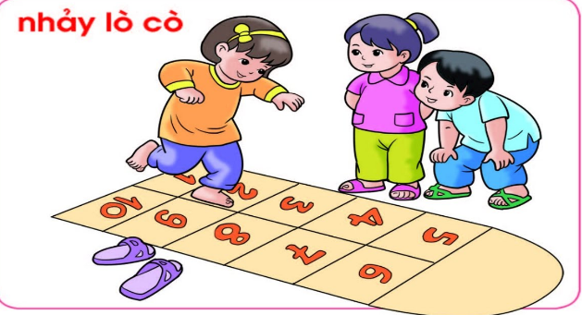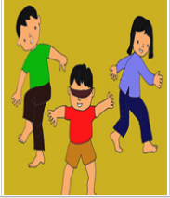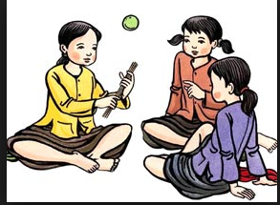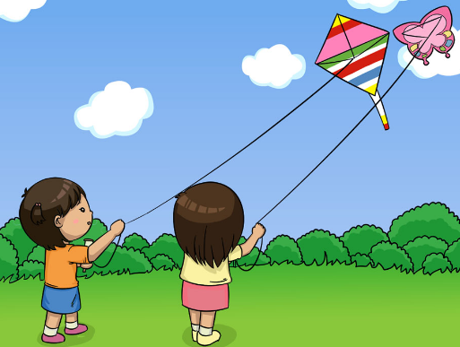  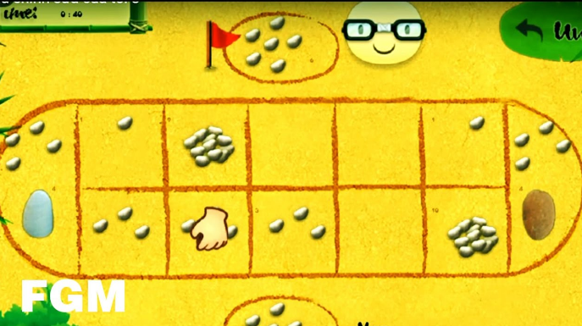  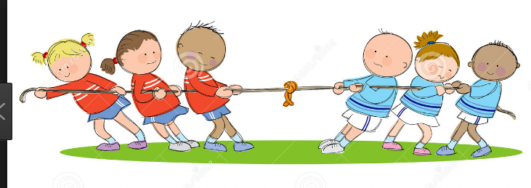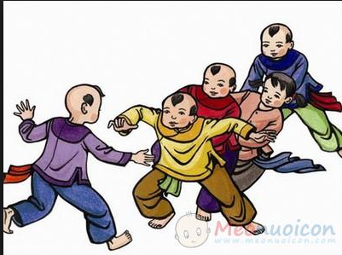  UNIT 4: LIFE IN THE PAST  LESSON 5: SKILLS 1 (page 46)
I. READING  Leading Sts to the new lesson by answering the pre - questions  TASK 1: Think (PW/5’)  - T asks Students to work in pairs to ask and answer:  1. How different is the way teenagers entertain themselves nowadays compared to the past?  2. What do you think might be the biggest difference?  - Brainstorm how teens entertained themselves in the past compared to the present. Make notes of the activities in two lists and leave them on the board while the class reads the conversation  TASK 2: Answer the questions (PW/5’)  - Have ss read the conversation individually and answer the questions in pairs.  - Check Ss’ answer as a class. Ask SS to show where the information for each answer appears.  - Answer the questions in pairs | I. Reading:  Ex1: Think:  Possible answer:  1.  2. Most outdoor activities >< indoor activities. Healthy life style  Ex 2: Answer the questions:  1. They used to play outdoors, in the fresh air.  2. They met and talked face-to-face.  3. It kept them healthy and in shape.  4. At home.  5. You had to use your own imagination.  6. No, they didn’t.
  Past | Now
  - blind man’s bluff  - hide and seek  - fishing  - land artillery/ Mud banger (phao dat)  - capture the flag  - spinning tops (con quay) | Watching TV.  surfing Internet.  Internet games/ computer games  playing in mall  Friends.  See Movies.  Reading.
SPEAKING(3’)  Leading students to the new lesson by focusing them on the passage about their  own family customs and traditions.  TASK 3: Discuss in groups: What do you think about teenagers’ pastimes in 2? (GW/7’)  - T asks Ss to read the example in 3 and the expressions for opinions and comments in the REMEMBER!  .- Once they are clear about what they have to do, they can read each pastime in the list and discuss what they think about it in groups of three or four.  - T should move around the groups and offer guidance.  - Group work  TASK 4: What do you think about these habits which have been long practiced by children in Viet Nam? Would you like to preserve them? Why/Why not?  - Apart from expressing an opinion on a practice in the past, Ss have to decide whether they would like to keep the practice alive and explain why.  - Allow Ss some time to read the practices, make their decision, and think of the reasons for their choice. They can then start their discussion.  - T moves around the class to facilitate the discussions.  If something interesting is expressed, T may wish  to bring the whole class together to discuss it. | II. Speaking:  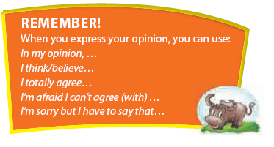  Ex 3: Discuss in groups: What do you think about teenagers’ pastimes in 2?  Suggested answers:  1. In my opinion / In my view doing physical activities in the fresh air great, but it’s hard to do in rainy weather.  2. I partially agree with using nature as our playground because when it’s too hot and rainy it’s hard to play outside’  4 Work in groups.  What do you think about these habits which have been long practiced by children in Viet Nam? Would you like to preserve them? Why/Why not?  1. hand-written homework  2. playing traditional games like hide and seek, elastic-band jumping, skipping, and catch the  Chickens.  3. crossing one’s hands in the front and bowing when you greet a person of seniority.  4. obeying your parents/teachers without talking back.
WRAPPING UP (PW/GW/5’)  - Summarize the dialogue.  - If time is enough, T can ask Ss to play a drama between mother/father and her son/daughter. The mother/father tells about their childhood. | - Summarize the dialogue.  - If time is enough, T can ask Ss to play a drama between mother/father and her son/daughter. The mother/father tells about their childhood.
HOME ASSIGNMENT  - T elicits Ss to do homework  - Copy down. | 1. Review this lesson  2 .Do exercises on C1,2 D1,2,3 (Workbook Page 34,35,36)

Feedback:
...........................................................................................................................................................
...........................................................................................................................................................
...........................................................................................................................................................
...........................................................................................................................................................

Preparing date: | Teaching date:
15/10/2022 | 9A: 19 /11/2022 | 9B:17 /11/2022 | 9C: 18/11/2022 | 9D:18 /11/2022
Period 33
UNIT 4: LIFE IN THE PAST
LESSON 6: SKILLS 2 (Activities 1- 6; page 47)

I. OBJECTIVES: By the end of the lesson, the students will be able to:
1. Knowledge: to know more about some traditional games.
- Listen for specific information about learning at school in the past.
- Write a short paragraph about learning in the past, write a description of how children in the past studied without technology.
- Vocabulary: The lexical items related to the topic “The past”.
- Grammar: Structures: pastime activities in the past; using “used to + V” to express habitual activities.
2. Skills: Listening, speaking, reading and writing.
3. Attitude: - Ss have a positive attitude towards what they have learnt; understand and actively respond to relevant matters or situations.
4. Competencies:
- Form and/or improve such competencies as collaboration, teamwork, communication, presentation, problem solving, assessment, etc.
II. PREPARATIONS:
Teacher: Projector, textbook, pictures, lesson plan.
Students: Textbooks, notebooks …
III. ANTICIPATED PROBLEMS AND SOLUTIONS:
Students may have difficulty in organizing the ideas to write a paragraph.
* Proposed solutions: Teacher should prepare the lesson carefully and give the Ss clear instructions
IV. PROCEDURE:
Students & Teacher’s and Student’s activities | Contents
WARM UP (GW/5’)
Helping Students revise some words about learning at school
* Brain storm
T asks Ss to play in two teams to write down all the words/ phrases related to learning at school.
If teacher sees that students are hard to find out actives teacher should recommend by asking some questions or looking at the picture given
- Ss play in two teams to write down all the words/ phrases related to learning at school.

I. LISTENING  Leading Ss to the new lesson by answering the pre - questions.  - T asks Ss to look at the picture and asnwer the questions (IW/5’)  1. Who are they in the picture?  2. Where is it?  3. What do you know about schools in the past?  TASK 1: Listen and decide if the statements are true, false, or not given. (PW/IW/7’)  - T asks Ss to look at the questions before listening work in pair to guess which information  -T then plays the recording and Ss tick the answers.  T can play the recording at least twice. Ss listen and do the task  - Elicit the answers from Ss. Ask them to explain their answers.  - Confirm the answers as a class.  TASK 2: Listen again and fill the blanks with the correct information (IW/7’)  T Asks Ss to listen again to fill in the gaps with the correct information  - Individual work | UNIT 4: LIFE IN THE PAST  LESSON 6: SKILLS 2 /page 47)  I. LISTENING  An old man is talking about his school days. Listen and decide if the statements are true, false, or not given.  Statements T F NG  Key:  1. F 2. T 3. T 4. NG 5. F 6. T  2 Listen again and fill the blanks with the correct information  1. 15  2. bare-footed  3. maths, history (in any order)  4. strict rules  5. extra classes
II. WRITING  Leading Students to the new section by focusing them on traditional Japanese dance  TASK 3: Make a list of the facilities you are using for your studies nowadays (GW/5’)  -T asks Ss work in group of four making a list of the facilities you are using for  your studies nowadays. Then tick the one(s) you think was/were not available about twenty years ago.  Present facilities for studies:  - Group work  TASK 4: Choose facility which was not available twenty years ago and write a short description of how students in the past study without that facility. (IW/10’)  - Ss work individually, referring to the framework while they are writing. If time allows,  - T can ask some Ss to share their writing with the | 3. Make a list of the facilities you are using for your studies nowadays. Then tick ( ) the one(s) you think was/were not available about twenty years ago.  Present facilities for studies:  1…………………………………..  2.…………………………………..  3.…………………………………..  4.…………………………………..  4. Choose one facility which was not available twenty years ago and write a short description of how students in the past studied without that facility.  In your writing, you should include:  - what facility it is  - what it is used for  - how students did the job in the past when they didn’t have it  - how you feel about the change  Sample writing:  It is most likely that students twenty years ago were not able to enjoy the Internet in their studies. That’s why it took them a lot of time, energy, and even money, to do a project that we can now easily complete in one or two days.  For example, when being asked to write an assignment about past habits, the students had to go to the library, look for books on the topic, read the books, and hand-write any information that they thought was useful for their assignment. They would also have to meet with some old people and talk to them about the past. At home, they had to hand-write their assignment, possibly with a lot of erasing and rewriting of the first draft. After finishing the draft, they had to write a clean copy on another piece of paper for submission.
WRAPPING UP (IW/5’)
- T asks students to present their lesson again and give comments.
HOME ASSIGNMENT (1’)  T elicits Ss to do homework  - Write down and listen to T’s guidelines | 1. Complete the writing  2. Do the exercises in Workbook unit 4 E1,2  3. Prepare Looking back and complete the project.
* Audio script: I went to a village school. In fact, there was only one classroom for 15 students of different ages, both boys and girls, and one teacher who taught everything. The school didn’t have a name, so we just called it ‘our school’. We used to walk to school. Some children went bare-footed.
At school we learnt to read and to write. We also learnt a little maths and history. There were no science lessons, and we didn’t have exams, either.
Although our school was small, it had strict rules. We had to behave ourselves. We stood up and bowed to greet our teacher at the start of every lesson. We could talk only when we were allowed to. However, we had no homework and no extra classes. I had a lot of time to play outside and to help my parents in the house. I loved my school and those school days.

Preparing date: | Teaching date:
15/10/2022 | 9A:22 /11/2022 | 9B: 21 /11/2022 | 9C: 22/11/2022 | 9D: 22 /11/2022
Period 34
UNIT 4: LIFE IN THE PAST
LESSON 7: LOOKING BACK AND PROJECT (P. 48 - 49)

I. OBJECTIVES: By the end of the lesson, the students will be able to:
1. Knowledge: Use the lexical items related to life in the past; Talk and write about life in the past (learning and entertainment); How to express personal opinions
- Vocabulary: The lexical items related to the topic “The past”.
- Grammar: Structures: pastime activities in the past; using “used to + V” to express habitual activities.
2. Skills: Listening, speaking, reading and writing.
3. Attitude: - Ss have a positive attitude towards what they have learnt; understand and actively respond to relevant matters or situations.
4. Competencies:
- Form and/or improve such competencies as collaboration, teamwork, communication, presentation, problem solving, assessment, etc.
II. PREPARATIONS:
Teacher: Projector, textbook, pictures, lesson plan.
Students: Textbooks, notebooks …
III. ANTICIPATED PROBLEMS AND SOLUTIONS:
Students are not confident to present and promote their activities before the class.
* Proposed solutions: Teacher should prepare the lesson carefully and give the Ss clear instructions
IV. PROCEDURE:
Teacher’s and Student’s activities | Contents
I. WARM UP (GW/5’)  Change game: I used to  - call 5 ss to the board and play the game  S1.I used to get up late when I was young  S2. I used to get up late and fly kites when I was young. | UNIT 4:  LESSON 7: LOOKING BACK  AND PROJECT
II. VOCABULARY  Leading students to the new lesson by using the words in the warm - up part.  TASK 1. Choose the best A,B,C to complete the sentences (IW/4’)  Have Ss complete this exercise individually. Check their answers as a class.  TASK 2  a) Match the verbs in A with their definition in B. (GW/3’)  - T Asks Ss to play in two teams to match the verbs in A with the definitions in B . Which team is faster can finish number 5.  Confirm the correct answers.  b) Use the verbs in A in their correct forms to complete the sentences. (IW/5’)  - Have Ss complete this exercise individually.  - Call 2 students to write their answers on the board  - Check their answers as a class.  - Individual work | I. VOCABULARY  1. Choose the best A,B,C to complete the sentences.  Key:  1. B 2. A 3.C 4.A 5. B  2a. Match the verbs in A with their definition in B.  Key: 1. b 2. e 3. a 4. c 5.  2b: Use the verbs in A in their correct forms to complete the sentences.  Key:  1. acting out  2. die out  3. preserve  4. collecting  5. entertains
III. GRAMMAR  Help students to review Grammar:  TASK 3: Write true sentences about the practice of the following things in the past using 'Used to' and 'didn't use to' (IW/5’)  - T asks Ss how to tell habitual activities using USED to  - Ss to do this exercise individually and then share and compare the answers with a classmates.  - T checks their answers and give marks  TASK 4.Read these situations and write wishes you want to make for them (IW/5’)  - Have Ss complete the exercise independently.  - T elicits the answers from Students.  - T encourages to have different answers.  - Ss share and compare the answers with a classmates.  TASK 5. T asks SS to look at the pictures to say the boy’s wishes.(IW/5’)  - T encourages Ss to use their imagination and work out wishes for the situation. Have them share their answers with the class.  - Individual work then share the answers with a classmates. | II. GRAMMAR  3: Write true sentences about the practice of the following things in the past using 'Used to' and 'didn't use to'  Suggested answers:  1. Men used to be the bread winner of the family.  2. Women didn’t use to go to work.  3. People didn’t use to travel on holiday.  4. Families didn’t use to be nuclear.  5. People used to make banh chung at Tet themselves.  6. Children used to play outdoor games.  4: Read these situations and write wishes you want to make for them.  Suggested answers:  1. I wish my village had access to clean piped water.  2. I wish there was/were a bridge over the river, so we did not have to cross the river by boat twice a day  to school.  3. I wish there was/were an organization for social activities for teenagers in my town.  4. I wish I was/were tall enough to play basketball.  5. I wish there were four seasons in my area./ I wish we had spring and autumn in my area.  5. Look at the pictures to say the boy’s wishes.  Suggested answers:  1. I wish it would stop raining.  2. I wish the wind weren’t blowing so hard.  3. I wish the sun were shining.  4. I wish I were sitting in a warm house.
IV. COMMUNICATION  TASK 6: Rearrange the sentences to make a meaningful conversation. (GW/5’)  - T asks Ss work in pairs or small groups to complete the exercise.  - Check as a class. Then asks them to practice the conversation  with their best pronunciation and fluency.  - Ss work in pairs, and then share and compare the answers with other pairs.  * Finished!  Ask Ss to complete the self-assessment. Discuss as a class what difficulties remain and what areas Ss have mastered. | COMMUNICATION  6. Rearrange the sentences to make a meaningful conversation.  Order: 1-4-5-2-9-7-8-6-3
V. PROJECT (GW/7’)  - This project aims to encourage Ss to do more research about the past with a focus on traditions and habits which are dying out.  - Divide Ss into groups of five and instruct them on what they have to do.  - Encourage them to interview previous generations - either members of their family or neighbors. Tell them to  - choose the pastime they most appreciate and would most like to preserve  - explain their choice  - work on a plan of how they can help to preserve it  - Have Ss present their posters in the next lesson. When all the groups have given their presentations, the whole class can vote for the best.  - Listen to the teacher’s instructions, then work in groups of 5 at home. | PROJECT: Preserving the past  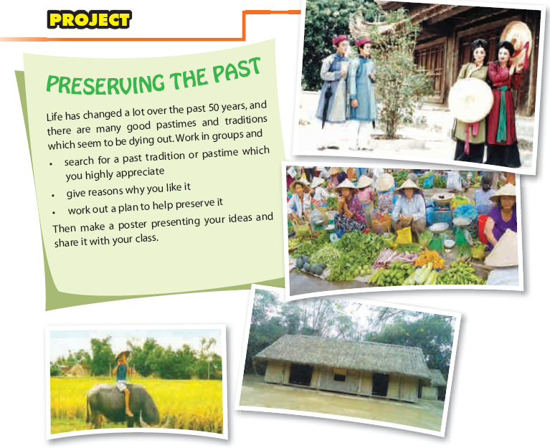
VI. HOME ASSIGNMENT (1’)  - T elicits Ss to do homework  - Write down and listen to T’s guidelines | - Complete ex in work book

Feedback:
...........................................................................................................................................................
...........................................................................................................................................................
...........................................................................................................................................................
...........................................................................................................................................................

