UNIT 6: OUR TET HOLIDAY
Lesson 2: A closer look 1
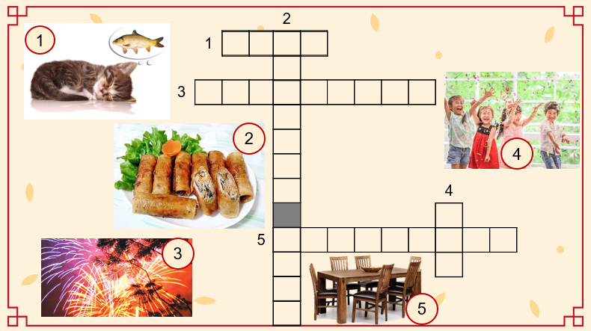
……………………………………………………………………………………………………………..
UNIT 6: OUR TET HOLIDAY
Lesson 2: A closer look 1

