UNIT 1. WHAT’S YOUR ADDRESS?
Exercise I. Odd one out:
- a. city b. town c. flat d. province
- a. house b. far c. near d. modern
- a. lane b. street c. stream d. avenue
- a. orange b. bread c. buildings d. noodles
- a. how b. village c. where d. who
- a. small b. quiet c. noisy d. center
- a. like b. jump c. skip d. dance
- a. island b. sea c. fish d. factory
- a. crowded b. countryside c. noisy d. modern
10.a. pretty b. bad c. nine d. beautiful
Exercise II. Look and complete:
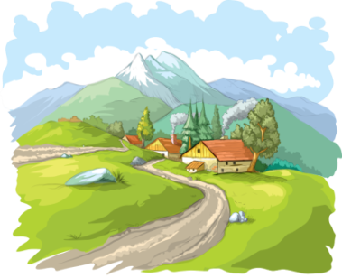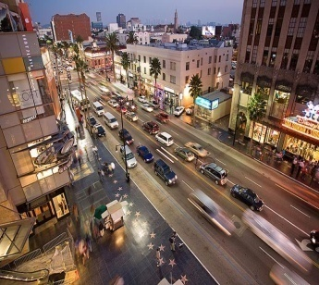
1. v i _ _ a g _ 2. m _ u n t _ i _ _ 3. t_ _e_ 4. a_en_e
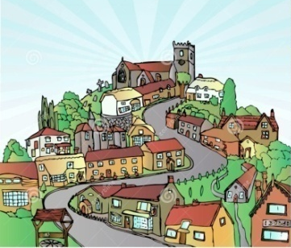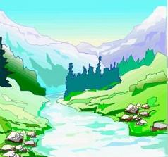
5. _ i t _ 6. t _ w _ 7. _ s _ a n _ 8. s_re_m
Exercise III. Choose the correct answer:
1.Ha Noi is a big ............. in the north .
A. street B. city C. town D. lane
2.His.......... is 187B, Giang Vo Street.
A. class B. road C. town D. address
3. There are two tall ........... in my street.
A. tower B. towers C. town D. mountains
4. Linda :Who do you live ........?
Mai : I live ........... my parents .
A. in – in B. for – for C. with- with D. at - at
5. Choose the odd one out ( the stress ) :
A. tower B. village C. city D. address
6. Ha Noi and Ho Chi Minh City are two big............. in the country.
A. city B. country C. cities D. countries
7. Mai : Where do you live , Trung ?
Trung : I live .......... Flat 18 ........ the second floor.............. Ha Noi Tower.
A. in - on – to B. of - in – on C. in - on – of D. on - in - in
8. His flat is far .... the city centre.
A. from B. to C. with D. of
9. Ha Noi is a big ............. in the north .
A. street B. town C. city D. lane
10. Choose the odd one out:
A. with B. from C. in D. city
Exercise IV. Complete withe the given words : cities city mountain village Tower floor hometown address
- Quang Nam ………………..……….. is my father’s hometown.
- My aunt and uncle live in a small ………………..……….. in the countryside.
- Her family lives on the third ………………..……….. of HAGL Tower.
- There is a big and tall ………………..……….. in front of my house.
- Da nang is one of the most beautiful ………………..……….. in Vietnam.
- Their ………………..……….. is 97B, Nguyen Van Cu Street.
- Truong Son is the longest ………………..……….. in my country.
- Peter’s ………………..……….. is London City in England.
Exercise V. Match the words that have opposite meaning:
- Old | - tall
- Small | - countryside
- Far | - noisy
- Short | - near
- Early | - large
- City | - late
- Quiet | - modern
Exercise VI. Put the words in order to make sentences:
- address / What/ Mai’s/ is?

- does / she/ Who/ with / live ?

- her/ Is/ house/ beautiful?

- 56 Nguyen Trai/ is / Street/ It.

- she/ Where/ does/ live?

- Danang/ hometown/ His/ city/ is.

- hometown/ like/ What/ his/ is?

- small/ quiet/ village/ and/ It/ is.

- you/ Do/ your/ live/ with/ parents?

Exercise VII. Translate into English.
- Địa chỉ của bạn là gì?

- Bạn sống cùng với ai?

- Quê của bạn ở đâu?

- Quê của bạn trông như thế nào?

UNIT 2.
I ALWAYS GET UP EARLY. HOW ABOUT YOU?
Exercise I. Put the verb in bracket into correct tense:
- Every morning, Thu (get) ............... up at 6. She (have) ............... breakfast at 6.10. After breakfast she (brush) ............... her teeth. She (go) ............... to school at 6.30. She (have) ............... lunch at 11. 30 at school.
- We (watch) ............... television every evening.
- I (do) ............... my homework every afternoon.
- Mai and Lan (play) ............... games after school.
- Vy (listen) ............... to music every night.
Exercise II. Fill the correct word into the gap.
- He’s a new pupil…......our class
- …...........is your address in Ha Noi?
- Now I live…........my grandparents in Ha Noi
- I live........…Flat 16 on the second floor of Ha Noi Tower
- I lived in …..........village in the mountain
- What’s your village….....…? It’s small and quiet
- The family lives….the third floor of CM Tower.
- His flat is far….the city centre
- His new school is…..his house
- Their flat is big….modern
Exercise III. Match A with B.
A |  | B
- Who’s this? |  | - She goes to school at 6.30
- What’s her name? |  | - Fine, thank you.
- Is your house big? |  | - It’s Lan.
- Is Mr. Tan an engineer or a doctor? |  | - Her name’s Thu.
5.How are you? |  | - We live on Tran Phu street.
6. Where do you live? |  | - She is a nurse.
7.How many students are there in your class? |  | - I’m in grade 6.
8.What does your mother do? |  | - There are 30.
9.Which grade are you in? |  | - He is an engineer.
10. What time does Lan go to school? |  | - Yes, it is.
Exercise IV. Put the sentences into the correct dialogue.
- What time do you go to bed?  B. What do you do after school?  C. I have my lunch.  D.Yes, I play volleyball.  E. I do my homework and then watch TV.  F. Do you play sports in the afternoon?  G. What do you do in the evening?  H.I go to bed at ten o’clock. | 1.  2.  3.  4.  5.  6.  7.  8.

Exercise V. Fill in the gap.
- Nam ............... soccer every day.
- She ............... to school ............... the morning.
- We ............... english on Monday.
- There ............... forty students in my class.
- Thu ............... up at five o’clock.
- She ............... her teeth after breakfast.
- My Mom ............... up at five o’clock.
- I live ............... a village.
- My class is ............... second floor.
- Which class is he ...............?
Exercise VI. Find and correct the mistakes.
- What is your first class in Monday?
- I goes to school on 6:45.
- She have her breakfast at home.
- Does you play sports?
- When do we has history?
- Does she wash she face?
- What time she get up?
- How many floors does your school has?
- This is Nga school.
10.Is Nam’s school at the country?
Exercise VII. Rearrange the sentences.
- is/ my/ this/ school?
...................................................................................................................................
2. Thu’s / is/ small/ house/.
...................................................................................................................................
3. students/ are/ there/ hundred/ nine/ school/ in/ the.
...................................................................................................................................
4. book/ is/ there/ desk/ in/ the/ a.
...................................................................................................................................
5. on/ the/ is/ classroom/ my/ second/ floor.
...................................................................................................................................
6. housework/ do/ you/ the/ do/ day/ every?
...................................................................................................................................
7. from/ i / past/ eleven/ seven/ to/ quarter/ classes/ have/ a.
...................................................................................................................................
8.o’clock/ at/ go/ I / bed/ ten.
...................................................................................................................................
9. tuesday/ have/ we/ history/ on/->..........................................................................
UNIT 3: WHERE DID YOU GO ON HOLIDAY?

Exercise 1: Chọn từ có phần gạch chân được phát âm khác:
1/ A. went B. where C. never D. get
2/ A. trip B. did C. with D. nice
3/ A. Bay B. play C. stay D. watch
4/ A. back B. taxi C. last D. parents
5/ A. coach B. ancient C. come D. country
Exercise 2: Chọn từ có trọng âm khác:
6/ A. holiday B. ancient C. imperial D. summer
7/ A. photo B. seaside C. island D. about
8/ A. motorbike B. countryside C. underground D. information
Exercise 3: Chọn đáp đúng để hoàn thành câu:
9/ I went ……... a trip with my family.
A. in B. on C. at D. of
10/ What was the trip …….?
A. is B. was C. like D. were
11/ ……… did you go on holiday?
A. What B. Where C. Which D. How many
12./ She went to Hoi An Ancient ………
A. city B. village C. town D. island
13/ Where ……… you last summer?
A. are B. was C. were D. is
Exercise 4: Chọn từ điền vào đoạn hội thoại:
Like photo was go last took island
Linda: Where were you (11)………… summer, Peter?
Peter: I (12)……… at the seaside.
Linda: Where did you (13)………..?
Peter: I went to Phu Quoc (14)……………
Linda: What did you do?
Peter: I (15)…………. a boat trip.
Linda: What was the trip (16)…………?
Peter: It was great.
Linda: What’s that?
Peter: It’s a (17)…………. of my trip.
Exercise 5: Nối cột A với cột B để được câu hoàn chỉnh:
A | B
18. Where were you on holiday?  19. Where did you go?  20. What was the trip like? | a. I went to Ben Thanh Market with my uncle.  b. It was very nice.  c. I was in Ho Chi Minh City.
21. He went to the | d. get to Sam Son ……………?
22. We went back to our | e. with my family.
23. Yesterday, we went to see | f. park ………. underground.
24. How ………. you | g. hometown by train.
25. Last weekend, I went to the seaside | h. our grandparents ……… the village.
Exercise 6: Chọn câu hỏi đúng nhất cho phần gạch chân trong câu trả lời:
26/ ………………………………………………………………………..?
I went to Da Nang City last summer.
27/ ………………………………………………………………………..?
I went by motorbike with my father.
28/ ………………………………………………………………………..?
I went to see my grandparents.
29/ ………………………………………………………………………..?
Yes, I did. It was fantastic.
Did you enjoy the trip? Who did you go to see?
Where did you go on holiday? How did you get there?
Exercise 7: Dịch đoạn văn sau sang tiếng Anh:
Tớ tên là Minh. Mùa hè năm ngoái, gia đình tớ đã đi đến Huế bằng tàu hỏa.
Nhà tớ đến để thăm ông bà của chúng tớ.
Chúng tớ đã đến thăm kinh thành Huế.
Chuyến đi của tớ rất tuyệt vời!
.....................................................................................................................................
..................................................................................................................................... ..................................................................................................................................... .......................................................................................................................................
Exercise 8: Khoanh vào từ có phần gạch chân phát âm khác với các từ còn lại.
1. A. fever B.elephant C. never D. eleven
2. A. watch B. beach C. chef D.chicken
3. A. weather B. healthy C. wear D. seasons
4. A. . what B. who C. where D. when
Exercise 9: Khoanh vào từ khác loại
1. A. farmer B. cashier C. brother D. singer
2. A. third B. seven C. second D. sixth
3. A. wear B. work C. use D. went
4. A. funny B. sunny C. rainy D. windy
Exercise 10: Chọn đáp án đúng A,B,C hoặc D (2đ)
1.I am going to go bowling............Jane.
A. on B.to C. by D.with
2. I ..........to the supermarket yesterday.
A. went B.go C. goes D.going
3.Ngo Quyen was born in...............
A. 986 B.897 C. 985 D.984
4.In the spring,It's.................
A.rain B.cold C. rainy D.snowy
5. He is from China. He's.......................
A. Chinese B.Japanese C. Singaporean D.American
6.What do students do...........Teacher's Day in Viet nam?
A.in B.for C.to D.at
7.My brother ................to be a teacher when he grows up.
A.want B. to want C. wants D.wanted
UNIT 4: DID YOU GO TO THE PARTY

Exercise 1: Put the correct form of the verb in past participle. | Exercise 2: Choose the correct one.  1. _____ you go to Mai’s party last Sunday?  A. Did B. Are C.Were D. Does  2. Did Mary ___ to the zoo with her parents?  A. went B. go C. goes D. going  3. Yesterday, I ___ at home and ___ TV.  A. stay/ watch B. stayed/ watch  C. stay/ watched D. stayed/ watched  4. Did they enjoy their holidays? – Yes, ___.  A. they do B. they did C. they were D. they didn’t  5. We had a lot of ____at the party.  A. funny B. fun C. nice D. great
  do | Did
  go
  have
  enjoy
  Think
  join
  watch
  visit
  stay
Exercise 3: Find a mistake and correct it in each sentence.
1. Last week, my brother and I join a sports festival. ___________
2. What did you did at the fun fair last month? ___________
3. Did you stay at home and watch TV? – No, I did. I went to the park. ___________
4. Who did you meet on the party? ___________
5. He bought 2 comic book at the book fair. ___________
Exercise 4: Match column A with a suitable one in B.
A |  | B
1. Where were you yesterday? |  | a. It was really wonderful.
2. Where did you go? |  | b. I bought some books.
3. What was the trip like? |  | c. I went there by coach.
4. Who did you go with? |  | d. It was yesterday.
5. What did you do? |  | e. I went to Da Lat.
6. When was Nam’s birthday party? |  | f. No, I didn’t. I went by train.
7. Did you get to Ha Noi by plane? |  | g. I went with my family.
8. How did you get to Da Nang City? |  | h. I was at the book fair.
Exercise 5: Find the word which has different stress with the others.
1. A. cartoon B. picnic C. water D. Monday
2. A. party B. repeat C. birthday D. comics
3. A. return B. invite C. complete D. festival
4. A. present B. family C. enjoy D. wonderful
Exercise 6: Translate into English.
1. Ở bữa tiệc, tôi chơi đàn piano còn Lâm chơi đàn ghi-ta.

2. Bạn và các bạn của bạn đã làm gì ở hội chợ sách?

3. Họ đã gặp rất nhiều bạn ở công viên.

Exercise 7: Arrange words to make meaningful sentences:
- get up / breakfast / time / father / and / your / have / what / does ?
…………………………………………………………………………………….
- country / it’s / in / house / the / is / small / Ha’s / and .
…………………………………………………………………………………….
- cities / there / country / how / are / your / in / many ?
…………………………………………………………………………………….
- island/ get/ did/ family/ how/ your/ to/ Phu Quoc/?
…………………………………………………………………………………….
- every / school / Jane / morning / eight / to / o’clock / goes / at .
…………………..
- in the city / in the country / Hung / or / does / live ?
…………………………………………………………………………………….
- part/ in/ festival/ did/ the/ sports/ you/ take/?
…………………………………………………………………………………….
- Hoa/ birthday/ to/ her/ invited/ Minh/ party/.
………………………………………………………………………………………
- Birthday/ went/ my/ my/ family/ to/ cousin’s/ party/ night/ last/.
…………………………………………………………………………………………
- what/ do/ Mid-Autumn Festival/ you/ did/on?
……………………………………………………………………………………….
- by/ classmates/on/trip/ zoo/ my/ a/ went/ to/ the/ bus/.
………………………………………………………………………………………..
- enjoyed/ we/ the/ and/ food/ at/ drinks/ the/ party/.
…………………………………………………………………………………………
Exercise 8: Put “DID, WAS or WERE” into the brackets:
- Where …………………you born? Where …………………your mother born?
- When …………………you start school?
- How many schools …………………you go to ?
- What …………………your favourite subject?
- Where …………………you live when you …………………a child?
- …………………they live in a house or a flat?
- I ………………… home to help my parents.
- What ………………… the trip like?

UNIT 5: WHERE WILL YOU BE THIS WEEKEND?

Exercise I. Fill in the gap with suitable letter
- T__in__ | - M__y | - __xpl__re | - C__v__ | - __oa__
- __ui__d | - S__nd__as__le | - I__lan__ | - Se__sid__ | - W__l__
Exercise II. Read and match:
- Where will you be this weekend?  - Where will Mai be tomorrow?  - Where will Hung be next weekend?  - What will your family do this weekend?  - Will you visit Tuan Chau Island?  - Where will Tom and Peter be next month?  - What will you do at Ha Long Bay?  - Why will you be at home, Hoa? | - They’ll be by the sea.  - I think I’ll swim in the sea.  - He’ll be in the mountains.  - I don’t know. I may explore the caves.  - Because I have to study.  - I think we will go for a picnic.  - She’ll be on the beach.  - I think I’ll be at home. | - …..  - …..  - …..  - …..  - …..  - …..  - …..  - …..
Exercise III. Put the words in correct orders:
- I /the/ I’ll /caves/ explore think/.

- know /He /doesn’t/. /He/ boat/ may/ the/ take/ a /trip/ islands/ around/.

- Phuong/, /build/ Tuan/ and/ Hoa/ may/ beach/ sandcastles /the/ on/.

- My/ will/ the/ family/ and/ sea/ I/ swim/ in/.

- Seaside/ They’ll /be /the/ on/ at /Sunday/.

- islands/ She’ll /Monday/ visit/ the/ on/.

- be/ Where/ will/ Saturday/ you /on/?

- and /I /think /school /Mai/ I /be /at/ will/.

- countryside /The/ will /month /boys/ be/ in/ the/ next/.

- I/ think/ tomorrow/ I’ll /the/ mountains /visit/.

- countryside /We /picnic/ will/ for/ a/ in/ go /the/.

- week/ the/ They/ seaside/ will/ be/ at/ next/.

Exercise IV. Choose the best answer:
- .......... is your telephone number ?
a. When b. Which c. What
- Her birthday is .......... Friday, August 20th.
a. at b. on c. in
- .......... you have a test tomorrow morning ?
a. Will b. Do c. Are
- Will he be free ? - ...........
a. No, he won’t b. No, he doesn’t c. No. he isn’t.
- We will .......... our old friends next Sunday .
a . to meet b. meet c. meeting .
- .......... meet at 7.00 p. m .
a. Let’s b. Let’s go c. Let .
- Nhat .......... 9 on his next birthday.
a. is b. will c. will be.
- I live .......... my parents in the countryside.
a. on b. with c. to
- Nga lives .......... 52 Nguyen Dinh Chieu Street.
a. at b. on c. in
- Will you be free tomorrow evening ? - ...........
a. Yes, I will b. Yes, I do c. Yes, I am
- Where will we meet ? - ...........the cinema.
a. In front b. Next c. In front of.
- I think she ........... the party tomorrow.
a. will enjoy b. enjoy c. enjoys.
- I will see you ..........tomorrow.
a. on b. Ø c. in
- Her sister is out when he calls.
a. not at home b. not busy c. late
- I will invite all of my friends .......... my birthday party.
a. to b. Ø c. come
- .......... you be free to morrow?
a. Will b. Are c. Have
- The book is open in front .......... her on the desk .
a. of b. to c . with .
- Will you be free on Sunday?
a. not at home b. not busy c not late.
- You will have .......... new friends soon.
a lot of b. lots of c. a & b.
- I hope he .......... to the party.
a. will come b. come c. came .
Exercise V. Fill in the gap with “What, Where, When, Who, Why, How, What time”:
  - . will they do tomorrow? - I will do my homework.
  - . will go camping next Sunday? - Nam and Quang will.
  - . will we meet? - We will meet at Lan’s house.
  - . .will you be back? - I will be back at 8 O’clock.
  - . will she go to the zoo? - She will go by bus.
  - . will your father travel to Ha noi ? - He will travel next week.
  - . will Nam go to bed early tonight? - Because he will have a test tomorrow.
  - . will Nam go to next summer vacation? - I will go to Nha Trang .
Exercise VI. Fill in the gap with “from, to, on, in, at”:
- They often go swimming ……….. Sunday.
- The meeting will last ………..7a.m ………..5p.m.
- She will be 13 ………..her next birthday.
- We are playing chess ………..the moment.
- It often rains ………..July.

UNIT 6: HOW MANY LESSONS DO YOU HAVE TODAY?

Exercise I. Arrange these letters to make correct school subjects.
1. ishElgn:
2. sathm:
3. ssleon:
4.umsic:
- sicalphy ucaedtion:
- escenci :
- rta:
- mVsietneea:
Exercise II. Complete the dialogue with the words from the box.
What time too timetable an favorite will Physics lessons
Phong: I don’t have my (1) ................................. .What do we have today, Minh?
Minh: We have Maths, (2) ................................., History and English.
Phong: (3) .................................do we have Physics?
Minh: We have it from 7:45 to 8:30.
Phong: What (4) .................................will we have tomorrow?
Minh: We (5) .................................have Geography, Art, Music and Physical Education.
Phong: What is your (6) .................................subject, Minh?
Minh: I like Math. It’s (7) .................................interesting and important subject.
Phong: Yes, I like Math (8) ..................................
Exercise III. Choose the correct word or phrase
- He is a student ........Le Loi School.
a. at b. in c. on d. for
- The class ........at 7 o’clock in the morning.
a. starts b. start c. end d. ends
- ........are you talking to? – I am talking to my friend, Thanh.
a. Who b. Which c. When d. What
- ........do you go to bed?- At half past ten.
a. What b. When c. Where d. What time
- ........does Nga have English? – On Monday and Tuesday.
a. When b. How long c. How far d. What time
- ........lessons do you have today? – We have four lessons.
a. How far b. How much c. How many d. What time
7. Mai goes to school........ a week.
a. five time b. fifth time c. five times d. five
8. How many ........ does Hung have on Wednesday?
a. lesson b. lessons c. class d. classroom
Exercise IV. Rewrite the words in correct order to make meaningful sentences.
1. favorite/ Art / Music/ her/ subjects/ are/ and/.
.......................................................................................................
2. Students / have / on / lessons / Vietnamese / Saturdays/.
.......................................................................................................
3. English / have / students / don’t / on / lessons / Saturdays/.
.......................................................................................................
4. have / in / only / on / they / lessons / morning / the / weekdays/.
.......................................................................................................
5. Maths/ My/ times/ class/ week/ have/ a/ lessons/ six/.
.......................................................................................................
6. have / in / exams / students / their / the / May/
........................................................................................................
7. always / homework / they / their / in / evening / the / do/.
.......................................................................................................
8. is / television / moment / she / at / watching / the/.
.......................................................................................................
9. does/ How/ lessons/ she/ Thursday/ many/ have/ on/?
.......................................................................................................
10.They/ week/ have/ times/ lessons/ three/ a/ English/.
.......................................................................................................
Exercise V. Translate these sentences into Vietnamese.
- My lessons begin at 12:45 and end at 17:15.

- The last class begins at 16:30 and ends at 17:15.

- There are two breaks in the afternoon.

- The first class begins at 12:45 and ends at 13:30.

Exercise VI. Choose the best suitable words to complete the passage.
At school we (1) ........many things. In Literature, we learn (2) ........books and write essays. In History, we study past and present (3) ........in Viet Nam and around the world. In (4) ........we study different countries and their people. In Physics, we learn about (5) ........things work.
In the (6)........class, we study English. We study (7) ........other things as well, such as Music, Sports and Art. We (8) ........all of our lessons.
- a. have b. study c. do
- a. with b. at c. about
- a. events b. things c. lessons
- a. Geography b. Physics c. Biology
- a. when b. what c. how
- a. Music b. Language c. Math
- a. much b. many c. any
- a. learn b. enjoy c. have
Exercise VII. Read the text and answer the questions
We go to school (1)………..days a week, from Monday to Friday, and we have a lot of subjects at school such as math, Literature, English, Geography, and so on. I always try my best to study all, especially English because it’s my (2)……………. subject .Math is a little difficult but (3)………… However, I don’t like Literature very much (4)…... the teacher gives us so many exercises. I’m not very good at Computer Science, so I’m really afraid (5)……………. this subject. Physics, Geography and History are the most useful subjects to me. We learn about the world, about life and nature. I’m rather interested in these subjects.
1. A. seven B. four C. five D. six
2. A. lovely B. likely C. favorite D. interesting
3. A. easy B. good C. lovely D. interesting
4. A. because B. but C. then D. and
5. A. for B. at C. of D. on
UNIT 7: HOW DO YOU LEARN ENGLISH?

Exercise 1: Fill in the blank with a suitable letter:
- __racti__e | - S__ea__ | - W__it__ | - E__ail | - __eca__se
- H bb__ | - __es__on | - Li__te__ | - T__lk | - R__ad
- W__rd | - Lea__n | - V__cab__lary | - Fo__ei__ner | - L__ng__age
Exercise 2: Fill in the blank with a suitable word: ………………………………
- I often ……………………………… English lessons on Wednesday and Friday.
- My brother …………………… watching English cartoon on TV.
- He ……………………………… new words in his notebook and reads them aloud.
- ……………………………… do you learn vocabulary?
- I speak English every day with…………………………friends.
- To practise speaking you can talk ……………………… foreign friends.
- He also learns English …………………… listening to English songs.
- What foreign ………… do you have at school? – I have English and Chinese.
- To practise ………………………………, I write emails to my friends.
- Why do you learn English? – …………………… I want to sing English songs.
Exercise 3: Read and match:
- How many English lessons do you have a week? | - I usually talk with foreigners.
- Who is your English teacher? | - Of course, very much.
- When do you have English? | - I listen to English songs and read English books.
- How do you practise speaking? | - Because I want to become an English teacher.
- What do you think about English? | - Yes, I do. We go to English Club together.
- How often do you watch English film? | - It’s Miss Huong.
- Do you help your friends learn English? | - I have it five times a week.
- How do you learn English? | - I sometimes watch after dinner.
- Do you like English? | - Mondays and Wednesdays.
- Why do you learn English? | - It’s a useful and interesting language.
Exercise 4:Make questions for the following answers:
- .
I have English on Wednesday and Friday.
- .
Because I want to talk with foreigners.
- .
He often read English books in his free time.
- .
By writing emails to her friends.
- .
Yes, I love English.
- .
No, we don’t have English on Tuesday.
- .
Mai learns English by singing English songs.
- .
I write them in my notebook and read them aloud.
Exercise 5: Find and correct the mistake:
- She practises listen by listening to English songs.
..............................................................................
- I write new words in my notebook and reads them aloud.
................................................................................
- He writes new words in a small note and stick it on the wall in his bedroom.
...............................................................................
- Mai learns often to speak English by herself.
............................................................................
5. Hung and Tuan usually writes email to their foreign friends.
............................................................................
6.My mother like learning English too.
............................................................................
7.She learns English because she wants have a good job in the future.
............................................................................
8.You can learn English with singing English songs.
............................................................................
Exercise 6: Read the text carefully:
My name is Linh. I’m a pupil at Kim Dong Primary School. I’m in class 5A with Lee and John. I love reading comic books. I often read them in my free time. When I see a new word, I try to guess its meaning. I write the word in my notebook and say it many times. I often stick new words on my bedroom walls and practise reading them aloud.
Lee and John love learning English too. We often learn to speak English by talking with our foreign friends in our free time. Lee is very good at English. She usually practises listening by watching cartoons on TV. She learns to write my writing emails to her friends every day. John loves reading. He goes to the library twice or three times a week. He usually read English books to practise reading. They always help me to learn English. We are happy because we can understand each other. English is necessary for communication.
A. True or False:

- Linh, Lee and John are in class 5A.
- They love learning English.
- Lee loves reading English books.
- Linh likes watching cartoons.
- They can understand each other.
- John sticks new words in his bedroom..........
Exercise 7: Put the words in correct order:
- I /English/ by /speaking /learn/it /day /every/.

- Subject/ English/favourite/ is /my/.

- How /Mai /often/ have/ do /you /English/,/?

- I /times /have /a /English /four /week/.

UNIT 8: WHAT ARE YOU READING?
Exercise I. Choose the odd one out:
- A. fox B. crow C. lamp D. hare
- A. kind B. gentle C. story D. clever
- A. generous B. hard-working C. brave D. character
- A. reading B. evening C. speaking D. helping
- A. ghost B. generous C. beautiful D. interesting

Exercise II. Fill in the stentence
swimming running walking surfing skiing shopping dancing sitting painting sleeping talking climbing
1. I am _____________.  2. I am ________________.
3. I am _____________. 4. I am ______________. 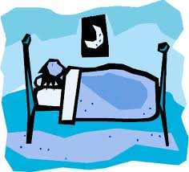
5. I am ______________. 6. I am ______________. 
7. I am ______________. 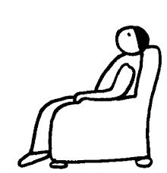8. I am ______________. 
9. I am _______________.10. I am ______________.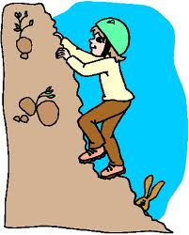
11. I am ________________.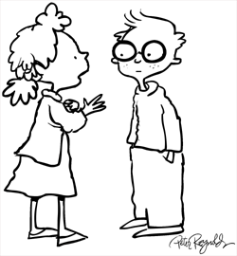12. I am _______________.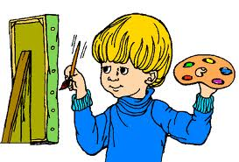

Exercise III. Reorder the sentences
- like/ What/ Seven Dwarfs/ are/ like?
...................................................................................................
2. books/ are/ reading/ What/ you/ ?
...................................................................................................
3. in/ your/ What/ do/ free/ you/ time/ do/ ?
........................................................................................................
4. She / and/ is/ The/ reading/ Crow/ Fox.
...................................................................................................
- He/ stays/ and/ home/ comic books/ at/ read/ often.
..................................................................................................
- story/ I/ reading/ am/ Cinderella/ the.
...................................................................................................
- in/ reading/ fairy tales/ her/ She/ time/ likes/ free.
...................................................................................................
- Is/ gentle/ very/ Tam/.
...................................................................................................
9. What/ you/ Quang/ reading/, /are/?
...................................................................................................
10. It’s /story/ two/ about/ Vietnamese /a /girls/.
...................................................................................................
11. character/ Who /the /main /is/?
...................................................................................................
Exercise IV: Fill in each gap in the passage with one suitable word and answer the questions
Today is Sunday . It is fine (1)_____warm . The Pikes (2)_______working in the house now . Mr Pike is cleaning the floor and (3)_________windows . Peter is (4)______him . Mrs Pike and Susan are in the (5)_________. Mrs Pike is (6)_______ the dishes . Susan is helping (7)_______.
The Pikes are (8)_________, but they are happy .
- Is the weather fine ?
...........................................................................
2. What is Mr Pike doing ?
...........................................................................
3. Where are Mrs and Susan ?
...........................................................................
4. Who is helping Mrs Pike ?
...........................................................................
5. Are the Pikes sad ?
...........................................................................
Exercise V. Fill in the blank with suitable letters:
1. C__mic | 4. C__ara__ter | 7. Gh__st | 10.k_nd
2. B__rrow | 5. G__ntl__ | 8. fair__ | 11. fini__h
3. Cl__ve__ | 6. Bo__k | 9. in__eresting | 12. be__ause

UNIT 9. WHAT DID YOU SEE AT THE ZOO?
Exercise I. Fill in the blank with a suitable letter:
1. s__o__ly | 6. p__nd__
2. ro__r | 7. __ov__
3. q__i__tl__ | 8. l__u__ly
4. __yth__n | 9. __o__il__a
5. p__ac__c__ | 10. b__a__tif__ll_
Exercise II. Read and match:
- Where did you go yesterday? | - Yes, I did. They were really noisy.
- What did the lions do when you were there? | - I saw a baby elephant and some other animals.
- When did you go to the zoo? | - They were big and moved slowly.
- Who did you go with? | - They roared loudly.
- Did you see any monkeys? | - Yes, the tigers were very fast.
- What is the elephants like? | - I went there at 8 a.m.
- What did you see at the zoo? | - By bus.
- Did you go to the zoo last weekend? | - No, I didn’t.
- How did you get there? | - I went there with my classmates.
- Did you see any tigers? | - I went to the zoo.
Exercise III. Put the words in correct order:
- Did /week/ you /to /the/ go /zoo/, /Phong /last/?

- did /the/ do /What /when/ you /there/ peacocks /were/?

- pandas /saw/ two /at /the /She /zoo/.

- are /the /your/ zoo /favourite/ animals/ What/ at/?

- moved /The /python/ slowly/ really/ and /quietly/.

- The /slowly /pandas /really /things/ cute/ were/ and/ did/.

- Mai /fast /the/ because /tigers/ they/ liked/ were/.

- The /down /monkeys /up /and/ very /jumped /quickly/.

Exercise IV. Read and complete:
A) bus – what – animals – zoo – how – where
- ................................. did you go last week?
- I went to the ................................. .
- ................................. did you go to the zoo?
- I went there by ................................. .
- ................................. did you see at the zoo?
- I saw a lot of ................................. .
B) like – go – big – slowly – zoo – animals
A: I didn’t see you yesterday. Where did you (1) ................................. ?
B: I went to the (2) ................................. .
A: What did you see there?
B: I saw some (3) ................................. . I enjoyed looking at the baby elephant.
A: What was it (4) ................................. ?
B: It was very (5) ................................. .
A: What did it do when you were there?
B: It moved (6) ................................. and quietly.
Exercise VI: Read the text and choose the correct and answers.
I am Linh Chi. I am at the zoo with my friend now. We often go to the zoo onece a month. We are at Thu Le zoo. Thu Le zoo is the biggest and the most beautiful zoo in VietNam. There are lots of animals here. This is a tiger. It looks strong and beautiful. These are some peacocks. They are colourful and beautiful. They move quietly. On the tree, there are some monkeys. They are eating bananas. They can climb very quickly. Look! There is a big crocodile. We don't like crocodiles very much because they look scary and dangerous.
- Where is Linh Chi now?
She is at................ ……………………………………………….
- How often does she go to the zoo?
She often goes to the zoo………………………………..………..
- What does the tiger look like?
It looks……………………………………………………..…….
- What are the monkeys doing?
They are eating………………………………………..………….
- Why don't they like crocodiles? Because they are………………………………
UNIT 10: WHEN WILL SPORTS DAY BE ?
Exercise I. Choose the odd one out
1. A.years | B.subjects | C. week | D.months
2. A.toothache | B.mouth | C. hand | D.stomach
3. A.travelled | B.visited | C.drove | D.speak
4. A.doing | B.going | C. swimming | D. spring
5. A.chinese | B.Japan | C.American | D. Vietnamese
6. A. Monday | B.Sunday | C.Friday | D.today
7 A.hot | B.weather | C.cold | D.warm
8. A.When | B.How | C.What | D.The
9. A.Subject | B.English | C.Science | D.Music
10. January | B. month | C. May | D. March
Exercise II. Complete the following sentences with WILL, using the verbs given in the box
borrow | invite | play | wear | buy
give | write | visit | see | have
1. We …………………………. our grandparents next weekend.
2. She …………………………. a letter to her friend.
3. I ………………………….some books from the library.
4. I ………………………….some close friends to my birthday party.
5. She …………………………. a blue dress at her sister’s wedding.
6. They ………………………….their holiday in Nha Trang.
7. They …………………………. their children toys at Christmas.
8. We …………………………. a play at the ABC Theater.
9. He ………………………….chess in the Youth Club.
10. Peter …………………………. some bread at the baker’s.
Exercise III. Complete the sentences with will or won’t.
1. It …………………………. be cold so take a warm coat.
2. I’ll get the news tomorrow so I …………………………. phone and tell you.
3. The sky is really blue so I don’t think it ………………………….rain this afternoon.
4. She’s intelligent. She ………………………….be a scientist one day.
5. It’s his first day at school so he …………………………. know anybody.
6. It is a secret so promise you………………………….tell anyone.
7. He is faster than me so I don’t think I …………………………. win the race.
8. I will leave early so I …………………………. be late.
Exercise IV: Read the text and choose the correct and answers.
My name is Phong. Today is Saturday. Tomorrow is the Sports Day of our School. All my friends will take part in this event. Nam and Tuan are going to play soccer. They play soccer very well. Thang and Manh are going to swim. They like swimming very much. Lan and Mai are going to play badminton. Hoa will play volleyball. She could play volleyball when she was seven. We will go to the stadium to practise for the event. I hope we will win the medals
1. When will Sports Day be?
A. yesterday B. tomorrow C. today D. next week
2. Who will take part in this event?

A. All Phong's friends B. Only Phong

C. Some of Phong's friends D. Only Phong, Nam and Tuan
3. What are Nam and Tuan going to do?
They are going to play..............
A. tennis B. badminton C. Volleyball D. soccer
4. Who are going to play badminton

A. Lan and Mai B. Phong C. Hoa D. Thang and Manh
5. Where do they practise for the event? - In a/an...................
A. park B. stadium C. school D. yard
Exercise V: Choose the best option to complete each sentence.
1. ………...........will Sport Day be? It’ll be on Sunday.
A. What B. Why C.When D. Who
2. Linda is.............to play badminton with Mai on Sports Day.
A. go B. going C. went D. goes
3. Our class will play.......................class 5A. Let's try hard!
A. about B. against C. to D. with
4. The......................is very large. We can play soccer there.
A. house B. playground C. bathroom D. bedroom
5. His favourite……............is science. He would like to become a scientist
A. time B. game C. subject D. colour
Exercise VI: Put the words in correct order.
a) going to do /you / What /Children’s Day, /Peter? / on / are /
……………………………………………………………………………………………
b) dancing /on /Teachers’ Day./ going to / take part in / the / contest / I’m /
……………………………………………………………………………………………
c) are /the football match. /practicing /for / We / hard/
……………………………………………………………………………………………
d) competition./ Mary / music / win / will / the/
……………………………………………………………………………………………

UNIT 11: WHAT’S THE MATTER WITH YOU?
Exercise 1. Complete the words:
1. To__tha__he | 6. S__re | 11. C__rry
2. F__v__r | 7. Fl__ | 12. B__cka__he
3. E__rac__e | 8. H__ad__che | 13. D__nt__st
4. __tom__chac__e | 9. __atte__ | 14. W__ll
5. P__in | 10. S__ou__d | 15. Do__to__
Exercise 2. Read and match:
- What’s the matter with you? | - She shouldn’t eat a lot of sweets.
- Nam has a toothache. | - I have a headache.
- Phong has a fever. | - She shouldn’t carry heavy things.
- Mai has a stomach ache | - He should go to the dentist.
- Quan’s grandmother has a backache. | - He should stay in bed.
- Miss Hien has a sore throat. | - She should take a rest.
- My mother has a headache. | - He shouldn’t watch much TV.
- His brother has sore eyes. | - She should take some warm water.
Exercise 3. Put the words in order to make sentences:
- What’s /your /the /with/ matter/ mother/?

- I/ a /throat/ sore /have/.

- eat /I /speak /can/ not/ or/.

- You /doctor/ should/ to/ the /go/
.
- Eat/ You /shouldn’t /ice-cream /
.
- to /should/ go /the/ He /dentist/.

- Should/ Mr. Tuan/ a/ take /rest/
.
- He / heavy /carry /shouldn’t/ things/
.
9. well/ I /feel /don’t/.

10. I /get/ you/ will /well /hope/ soon/

11. My /backache /has/ grandfather /a/
.
12. What’s/ your /the /with /matter /sister/?

Exercise 4. Complete the sentences with the following words:
Sore throat – backache – headache – toothache – stomach ache – fever
- Trung had a .................................... last week. He couldn’t speak.
- Nam went to the dentist yesterday because he had a .................................... .
- Quan is in bed and feels very hot. He had a .................................... .
- Phong’s grandpa has a .................................... . He can’t carry heavy things.
- Trung had a .................................... last night because he ate too much at dinner.
Exercise 5. Find the odd one out:
1. a. cough b. weak c. headache d. sore throat
2. a. stomachache b. toothache c. earache d. unhealthy
3. a. sick b. temperature c. tired d. weak
4. a. flu b. stomachache c. cold d. fat
5. a. sleep b. happy c. live d. smile
6. a. feel b. healthy c. well d. tired
7. a. fat b. big c. matter d. small
8. a. fever b. dentist c. nurse d. doctor
9. a. tooth b. pain c. stomach d. throat
10. a. her b. she c. him d. them
11. a. doctor b. mom c. nurse d. dentist
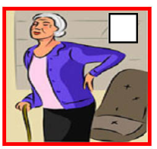
Exercise 6. Look and write
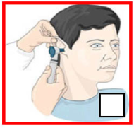
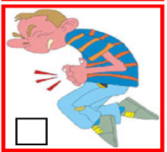



................. ………… ………… ………….. ……………..

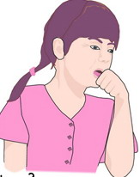
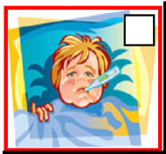
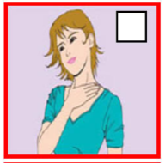

. ………… ……………… …………… ……………… ……………

UNIT 12: DON’T RIDE YOUR BIKE TOO FAST.
Exercise 1. Fill in the blank
- F_ST 4. CA_BAGE 7. MA_CHES 10.B_EAK
- TOU_H 5. BOR_D 8. S_AIR 11. DAN_EROUS
- C_IMB 6.K_IFE 9._TOVE 12. BURN
Exercise 2. Fill in the blank with suitable word
- What are you…...........................? I’m …...........................a cabbage.
- Don’t play with a …............................ You may cut yourself.
- He shouldn’t climb the tree because he …...........................and break his leg.
- Why …...........................I play with the matches? Because you may get a burn.
- They are …...........................the apple tree. They may fall.
- Mary shouldn’t …..............................too fast because she may fall off her bike and break her leg.
- Don’t …...........................the stove. You may get a burn.
- Don’t let your baby …...........................the bed.
- Linda is playing with a cat. It may …...........................her face.
- Falling is common type of …...........................for young children at home.
Exercise 3. Matching
1.Don’t play with the knife | a.Because you may fall.
2.Where are you, Tom? | b. I’m cooking some rice.
3.Don’t touch the stove | c. I want to light the candle.
4. why shouldn’t I climb a tree | d. OK, I won’t.
5.What are you doing, Mai? | e. He may fall off his bike and break his arm
6. What are you doing with the matches | f. I’m upstairs, Mum.
7. Look! Peter is riding his bike too fast | g. A knife
8. What are you holding in your hand? | h. You may get a burn.
Exercise 4. Read and answer the question:
Falling is common type of accident for young children at home. Your baby brother or sister may fall off a bed or a sofa. He or she may also fall down the stairs. The following tips can help to keep your baby brother or sister safe:
-Make sure he or she can’t roll off the bed.
-Make sure he or she can’t open any windows.
-Don’t let him or her go near the stairs.
-Don’t let him or her out on the balcony.
- What is the common type of accident for young children at home?
...............................................................................................................
- How to prevent a child from falling out of the windows?
...............................................................................................................
- What may happen if a child goes near the stairs?
................................................................................................................
- What should we do when a child is on the bed or a sofa?
...............................................................................................................
Exercise 5. Give the correct from of the verbs in the bracket
- Don’t (let) …...........................your child play with a knife.
- Mary (cook) …...........................in the kitchen at present.
- Where are you, Peter?I(be) …...........................upstairs, Mom.
- Jimmy(climb) …...........................the apple tree yesterday. He (fall) …...................and (break)…...........................his leg.
- Look! He(run)…...........................down the stair. He may break his arm.
- Mai has a toothache She (go)…...........................to the dentist tomorrow.
- Hoa (wash)…...........................her hair three times a week.
- Last Monday, My mother(have)…...........................a bad pain in her stomach.
Exercise 6. Choose the best answer
1) Don’t play with the knife ! …………………………
a) Yes, I do. b) Ok, I won’t.
2) Don’t …………………………the tree !
a) ride b) climb
3) Why shouldn’t he ride a bike too fast ? Because he may ……………the bike.
a) fall off b) go out
4) Why shouldn’t she play with the knife ? Because she may……………herself.
a) break b) cut
5) Why shouldn’t they touch the stove ? Because they may ……………a burn.
a) take b) get
6) …………………..shouldn’t I ride my bike too fast ?
a) Why b) Don’t
7) The children ………………………go to bed early.
a) shouldn’t b) should
8) Why shouldn’t I play with the cat ?
Because it may ………………………..you .
a) scratch b) cut
9) Don’t play with the dog. It may ………………………..you .
a) fall down b) bite
UNIT 13: WHAT DO YOU DO IN YOUR FREE TIME?
Exercise 1. Fill in the blank
1. S_RF T_E IN_E_NE_ 8. PL_Y C_ES_
2. C_NE_A 9. P_RK
3. _L_AN 10. SP_RT
4. K_R_TE 11. PR_GR_M_E
5. W_T_H 12. D_N_E
6. DR_W 13. S_RVEY
7. FR_E T_M_ 14. CA_T_ _N
Exercise 2. Fill in the blank with suitable word
1. What do you__________in your ______time ? I __________ cartoons on TV.
2. What ___ you doing? – I’m __________chess.
3. Hoa and I_______to the music club and _______ many songs.
4. Do you like________ sport programmes? – No, I ______. I like _________books.
5. What______you? What do you do in your free______? – I often ride a ______in the park.
6. What ____ your father do in _____ free time? - _______ goes fishing.
7. My sister __________ to music and _______ the Internet in her free time.
8. His mother_______________shopping _____weekends.
9. I _____ my house every day.
10. My friends often______ karate in the evening.
Exercise 3. Make sentences from given words
Ex: Father/ go fishing.
What does your father do in your free time?
– He goes fishing.
1. mother/ go to the cinema.
………………………………………………………………………………………………
................................................................................................................................................
2. you / surf the Internet.
………………………………………………………………………………………………
………………………………………………………………………………………………
3. sister / camping.
………………………………………………………………………………………………
………………………………………………………………………………………………
4. brother/play chess?
………………………………………………………………………………………………
………………………………………………………………………………………………
5. parents/read books.
………………………………………………………………………………………………
………………………………………………………………………………………………
6. Lan / go skating.
………………………………………………………………………………………………
………………………………………………………………………………………………
7. brother and sister/go to the zoo.
………………………………………………………………………………………………
………………………………………………………………………………………………
8. you/ music
………………………………………………………………………………………………
………………………………………………………………………………………………
Execise 4. Read and answer the questions.
My name is Nga. I’m 13 years old. In my free time, I often go swimming with my brothers. We often go swimming at weekends. My mother likes reading. She usually reads books in the morning. My father plays chess and watches sport programmes in his free time. My brothers and I like sports, so we often go hiking in the forest.
1. How old is Nga?
..............................................................................................................................................
2. What does she do in her free time?
..............................................................................................................................................
3. What does Nga’s mother like?
..............................................................................................................................................
4. What does Nga’s father do in his free time?
..............................................................................................................................................
5. What do Nga and her brothers like?
..............................................................................................................................................
6. Where do they often go hiking?
..............................................................................................................................................
Exercise 5 . Order the sentences.
1. the matter/ What’s/ you?/ with
What’s the matter with you?
2. Don’t/ your/ ride/ too fast!/ bike
..............................................................................................................................................
3. shouldn’t / the kids/Why/the dog?/ play/ with/
..............................................................................................................................................
4. ride / your/ Don’t / bike / fast/ too ! - I / won’t./ Ok,
..............................................................................................................................................
5. cutting / I’m / the / cabbage./
..............................................................................................................................................
6. touch /Don’t / stove !/ the / - may / You / a burn/ get
..............................................................................................................................................
UNIT 14: WHAT HAPPENED IN THE STORY?
Exercise 1.Translate into English.
1. hoàng tử:............................... 6. Hạt giống:.................................
2. quả táo thần:........................... 7. Trao đổi:...................................
3. lâu đài:................................... 8. Ra lệnh, yêu cầu:......................
4. kết hôn:................................. 9. Tham lam:.................................
5.nhân vật: .............................. 10.thú vị: .....................................
11. ngạc nhiên:......................... 12. Ngon:.......................................
13: loại....................................... 14. Tốt bụng:................................
Exercise 2. Choose the words above to fill in the blanks.
1. An Tiem recieved some ................................from the crow. He grew them.
2. Folk tales are usually short and ................................. They give me one surprise after another.
3. The ................................visited the castle and he met the beautiful princess.
4. The brother in the story was so ................................. He wanted to have all of the money.
5. The main................................in this story is Snow White.
6. The King ................................the princess not to go outside. The pricess was very upset.
7. In the past, people often ................................salt for food and drink.
8. My mother was very ................................when we had a big birthday party for her.
9. Linda is a................................person. She often help other people when they have trouble.
10. In the end, the Prince and the Princess ................................and lived hapily ever after.
Exercise 3. Change these words into past form:
- Order:....................................... 7.Take:...........................................
- Get: ......................................... 8. Read:.........................................
- Find:........................................ 9. Hear:........................................
- Meet:...................................... 10. Can..........................................
- Think................................... 11. Lose:........................................
- Is/am: .................................. 12. Stand:......................................
13. give: .................................. 14. Exchange................................
15. grow.................................. 16. Call........................................
Exercise 4. Reoder the sentences
1. they / and / lived / In / hapily / the end / got married / ever after.
..............................................................................................................................................
2. folk tales / I / because/ love / each of them/ me/ gives/ in life./ a lesson /
..............................................................................................................................................
3. Tam / gentle./ very/ beautiful / and/ was/
..............................................................................................................................................
4. does / Why / she / this / story / like?/
..............................................................................................................................................
5. think of / What / Linda / does / main / the / character / in / this story. /
..............................................................................................................................................
Exercise 5. Match the question with the suitable anwers:
- What book are you reading? | - I’m reading folk tales.
- What happened in the story? | - I think she is gentle and beautiful.
- What are you doing, Mai? | - He likes comic books
- What do you think of Snow White | - I like The story of Mai An Tiem.
- What kinds of story does Peter like? | - Because it gives her one surprise after another
- Who is the main character in this story? | - First, the prince visited the castle and he met a beautiful princess.
- Why does she like that book? | - I’m reading a book.
- What is your favorite book? | - The main character is Tam.
Exercise 6. Fill in the blank with the words in the box. Translate the story in Vietnamese
got married First cruel ordered fell in love(phải lòng)

Once upon the time, there was a beautiful girl named Tam. She lived with her father ,her step-mother and her sister,Cam in a small village (1)……………, Tam’s father died. Her step-mother (2)…………… her to do much housework. Tam was very upset. Cam was as (3)……………as her mother. She often made Tam be punished the mother. Then, one day, Tam met a King with the help of a fairy. The King( 4) …………… with her and he took her to his castle. Next, Cam and her mother found different ways to make Tam died but they failed terribly. In the end, Tam (5) …………… to the King and lived happily ever after.
New words: be punished: bị phạt die: chết upset: buồn
Step-mother: mẹ kế fail terribly: thất bại thảm hại
Translate the story in Vietnamese
………………………………………………………………………………………………….
………………………………………………………………………………………………….
………………………………………………………………………………………………….
………………………………………………………………………………………………….
………………………………………………………………………………………………….
………………………………………………………………………………………………….
………………………………………………………………………………………………….
………………………………………………………………………………………………….
………………………………………………………………………………………………….
………………………………………………………………………………………………….
………………………………………………………………………………………………….
………………………………………………………………………………………………….

UNIT 15: WHAT WOULD YOU LIKE TO BE IN THE FUTURE?
Exercise 1. Odd one out:
1. a. astronaunt b. architect c. doctor d. become
2. a. look after b. design c. hospital d. want
3. a. doctor b. student c. teacher d. hospital
4.a. pilot b. shop assistant c. policeman d. fly
5. a. once b. three c. two d. four
6. a. Music b. Science c. Monday d. Maths
7. a. am b. do c. is d. are
Exercise 2. Look at the picture and write the correct jobs
a) The person who looks after the patient is a ………………. | 
b) He likes drawing . He wants to be an …………………… | 
c) Tom would like to be a …………………… like his father. | 
d) I would like to be an ………………… because I would like  to fly a spaceship. | 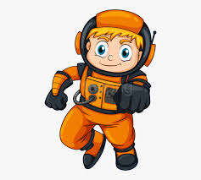
e) What would she like to be in the future ?  She’s like to be a …………………………….. | 
f) She wants to teach children . She wants to become a …………….. | 
g) He wants to design buildings . He wants to become an ……………. | 

Exercise 3. Match the jobs with the activities
- Pilot | - drive a car | 1- ……………
- nurse | - draw pictures | 2- ……………
- writer | - work in a field | 3- ……………
- architect | - grow flowers and plant | 4- ……………
- teacher | - teach children | 5- ……………
- astronaut | - write stories | 6- ……………
- gardener | - design building | 7- ……………
- driver | - look after patient | 8- ……………
- artist | - fly a plane | 9- ……………
10) farmer | - fly a spaceship | 10-……………
Exercise 4. Order the words. There is one example.
Example: a / doctor / like / to / he / future / in / would / the / be
He would like to be a doctor in the future.
1. you / do / to / you / what / like / would / grow / up ?/ when /
……………………………………………………………………………………………
2. you / to / where / work ? / would / like /
……………………………………………………………………………………………
3. is / your / dream / job, / Susan? / what
……………………………………………………………………………………………
4. old / look / she / people / to / would / like / after /
……………………………………………………………………………………………
5. job. / Maths / teaching / dream / is / my/
……………………………………………………………………………………………
Exercise 5. Read and choose the best answer.
1. He ………………… to be an astronaut in the future.
A. like B. would like C. want
2. My father is ………… engineer and he works in ………………… office.
A. a /an B. an /an C. an / a
3. ………………… would you like to be a pilot ?
A. Where B. What C. Why
4. Yesterday I ………………… to the English Speaking Club with my friends.
A. went B. go C. going
5. Linda loves children ………………… she wants to be a future.
A. and B. but C. because
UNIT 16: WHERE’S THE POST OFFICE?
Exercise 1. Odd one out.
- a. envelope b. stamp c. letter d. coach
- a. left b. right c. opposite d. welcome
- a. show b. take c. street d. tell
- a. shoe b. bakery c. drugstore d. restaurant
- a. need b. want c. could d. would
Exercise 2. Choose one word that has opposite meaning to the word in capitals.
- NEAR a. next b. far c. on d. at
- LEFT a. second b. opposite c. right d. between
- BUY a. sell b. send c. take d. cost
- GIVE a. write b. show c. tell d. receive
- ABOVE a. in b. under c. before d. after
Exercise 3. Choose the word or phrase that best completes each unfinished sentence below or substitutes for the underlined word or phrase.
- The supermarket is ............... of you.
a. near b. opposite c. behind d. in front
- How much does a letter to America..............?
a. is b. are c. take d. cost
- I would like....................a letter to America.
a. send b. to send c. sending d. to sending
- Could you tell me how................. there?
a. get b. to get c. getting d. to getting
- There is souvenir shop............. Tran Phu Street.
a. on b. at c. from d. to
- The bank is.............. the restaurant and the hotel.
a. opposite b. right c. in front d. between
- How .............is it from Hue to Ho Chi Minh City?
a. often b. far c. near d. All are correct
- I need .............a phone card.
a. buy b. to buy c. buying d. to buying
- I would like to send this letter.............. the USA.
a. for b. of c. to d. in
- How............... do you write to each other?
a. much b. many c. often d. far
- ...............go to the park?
a. Let’s b. Why don’t we c. Should we d. b & c
- His house is............... to my house.
a. behind b. in front c. next d. near
- How..............is it from your house to school?
a. long b. much c. far d. All are correct
Exercise 4. Choose the words or phrases that are not correct in Standard English.
- The toy store is next the bakery and the movie theater.
- A student needs do a lot of homework before tests.
- They would like buying a pen and some stamps.
- She wants to send a letter for England.
- There is a police station opposite to my school.
- I’d like to a teacher and I hope my dream will come true.
- There is a post office, a bank, a restaurant and a school on my neighborhood.
Exercise 5. Choose the word (a, b, c, or d) that best fits each of blank spaces.
Tourist: Excuse (31).............. . Could you show me the way (32)............... the museum, please?
Lan: The museum? Ok. Go straight ahead. Take the first street on the (33).......... The supermarket is (34)........... front of you.
Tourist: Thanks a lot.
Lan: You are(35)...............
- a. I b. me c. my d. Mine
- a. of b. for c. to d. At
- a. right b. left c. near d. a & b
- a. in b. at c. on d. ∅
- a. kind b. welcome c. nice d. pleasure
Exercise 6. Read and fill each gap with one word from the box. Write the word next to the number. There is one word that you do not need. There is one example (0).
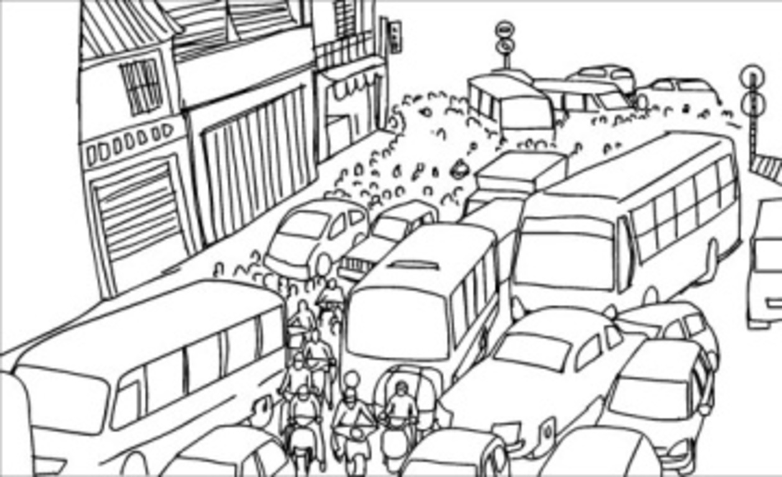  Jams | 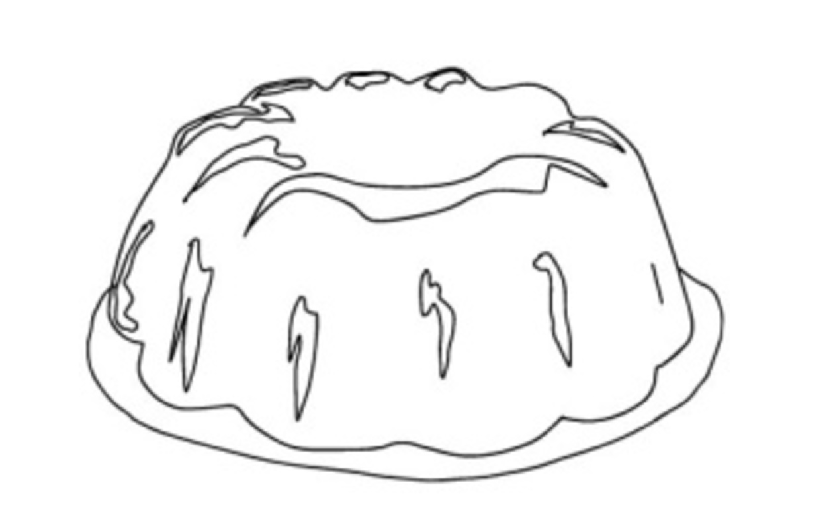  Jelly | 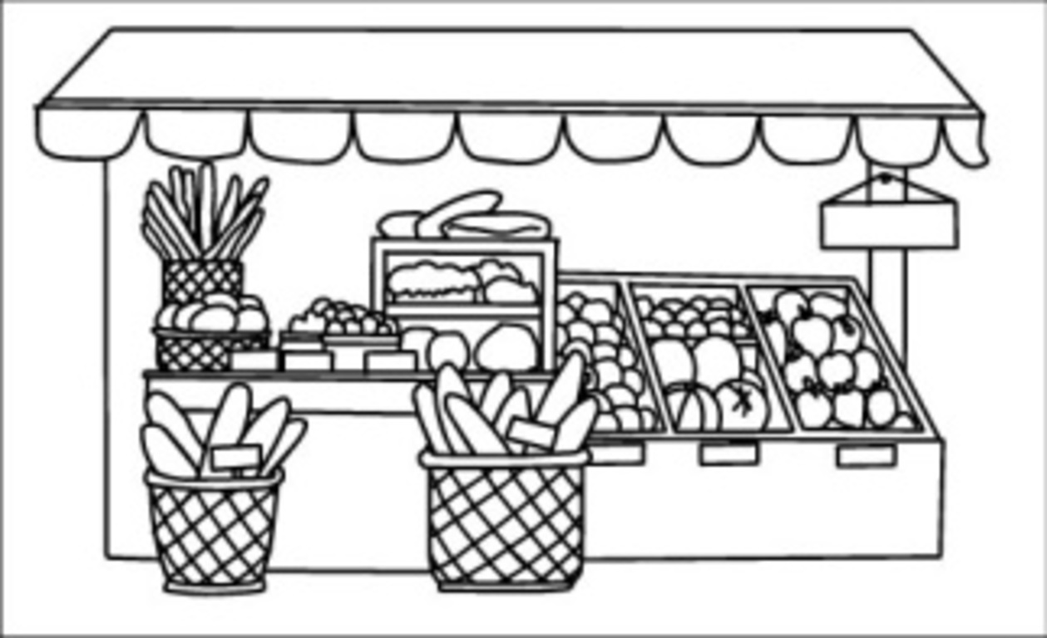  goods |   banks
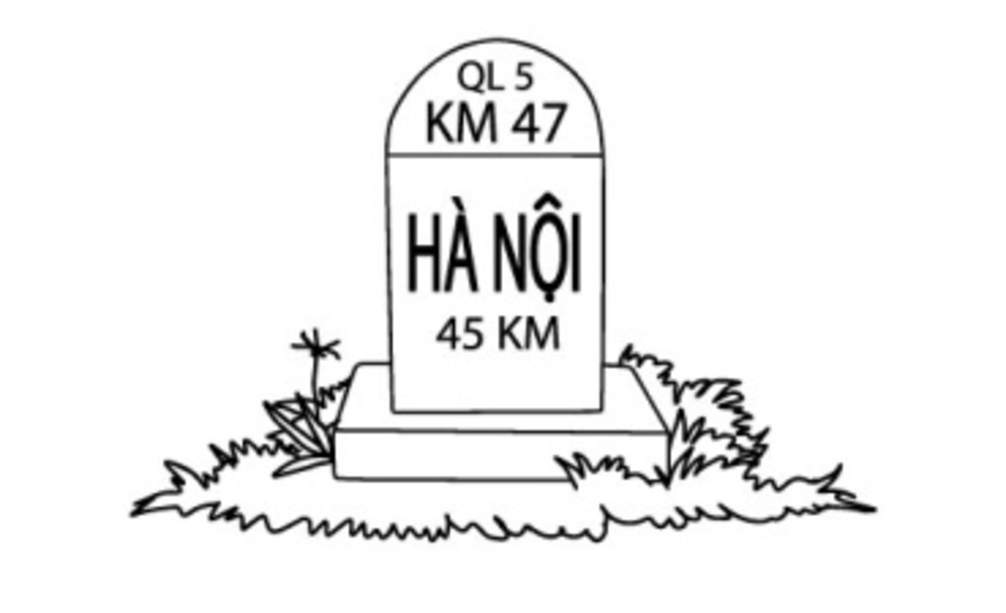kilometres | 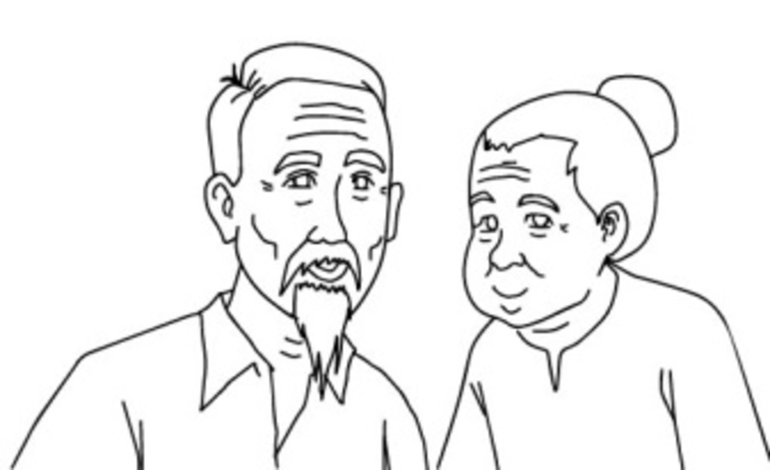  grandparents | 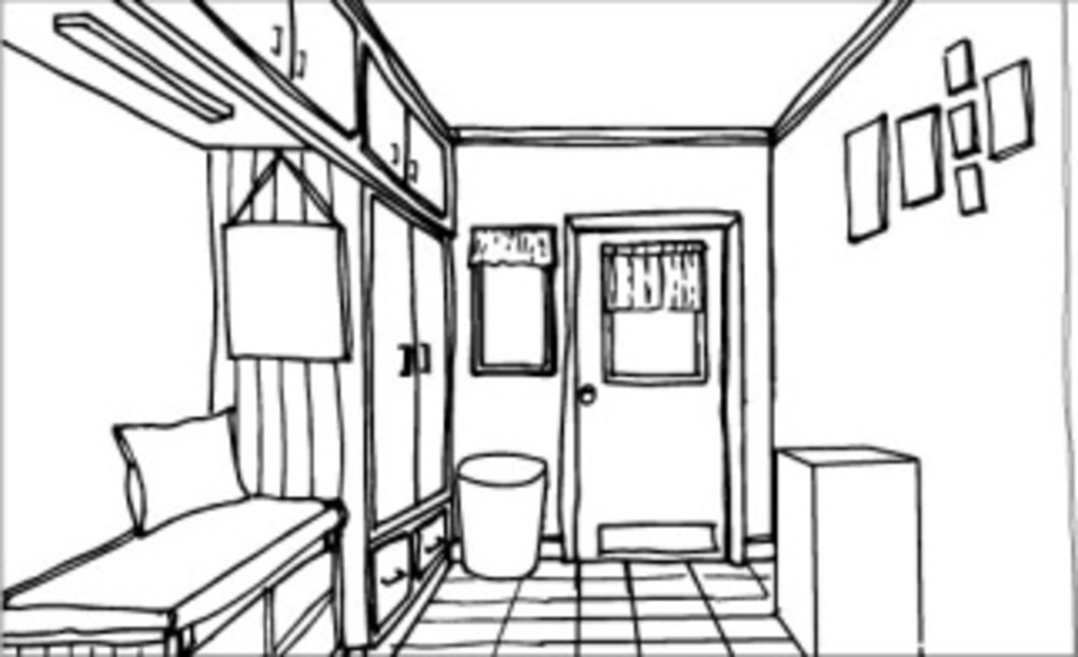  apartment
Kate lives in an (0) apartment in Sydney. It is a modern city. It has a lot of buildings, shops
and (1)______. There are often traffic (2)_________ during the rush hours. The city is noisy
and expensive. But Kate likes living here because life is exciting. At weekends, she oftens
visits her (3) ___________ in Brooklyn, a small town about fifty (4)__________ from Sydney.
There are not many people and shops there. The (5) _________ are much cheaper. There isn’t much traffic. Kate’s grandparents enjoy living there because the people are friendly.
UNIT 17: WHAT WOULD YOU LIKE TO EAT
Exercise 1. Odd one out:
- a. bowl b. cup c. sweet d. bunch
- a. banana b. bread c. orange d. apple
- a. noodles b. fish c. pork d. beef
- a. cabbage b. chocolate c. biscuit d. sweet
- a. milk b. bottle c. tea d. water
Exercise 2.Choose the best answer for each sentence:
- What’s your favorite drink? – ............
A. Chicken B. Orange C. Lettuce D. Soda
- What’s the matter? - I’m very hungry. I want some .............
A. knives B. iced tea C. lemonade D. sandwiches
- Which are your brother’s favorite dishes? - ............
A. No, thanks. B. I’m thirsty. C. Cartoons. D. Chicken noodles and apple pies.
- ............ is there to eat? - There’re some apples.
A. Who B. Where C. When D. What
- ............ do you feel? - I feel very hungry.
A. Who B. Why C. Which D. How
- We’re very ............ now. We don’t want any more food or drink.
A. cold B. hot C. full D. hungry
- I would like ............ orange.
A. a B. an apple C. much D. any
- Watermelon is his favorite ............ .
A. drink B. vegetable C. meat D. fruit
- We want five .............
A. milk B. bread C. melons D. cheese
- How about a ............?
A. meat B. cheese C. sandwich D. sugar
11. They have ............ apple juice.
A. apple B. some C. an D. any
12............ does Alice want? - She wants some ice-cream.
A. Who B. What C. How D. Why
13. It’s a good idea to drink............ juice between meals.
A. some B. these C. an D. any
14. I’m hungry. I want some ............ .
A. books B. cakes C. water D. pencils
15.Would you like ............ glass of hot milk?
A. a B. some C. any D. an
16.Lemonade is my favorite............ .
A. drink B. fruit C. meat D. vegetable
17.Tomatoes are very good............ you.
A. to B. at C. on D. for
Exercise 3. Complete the conversation with the following sentences. There is one example at the beginning.
- Is she making fish and rice?
- Mom cooks the best chicken noodles.
- No, she isn’t.
- She’s cooking dinner.
- She’s in the kitchen.
Huong: Hi, Phuong. Where’s Mom?
Phuong: (1)....................................
Huong: What’s she doing?
Phuong: (2).................................... .
Huong: Great! (3).................................... .
Phuong: (4).................................... .
Huong: Oh, too bad. Fish is my favorite. What’s she making?
Phuong: Chicken noodles.
Huong: It sounds good! (5)........................ .
Exercise 4. Fill in the blank with suitable words:
- You will get off the bus at the ...................................... on Tran Dang Ninh Street.
- My mother wants to send this letter for my uncle, so she goes to the ...................................... .
- Can you buy me a ...................................... of vegetables oil, Mai? – OK, mom.
- What would you like do drink? – a ...................................... of coffee, please.
- How much water does she drink every day? – 8 ...................................... of water.
- We’d like to buy some ........................... of biscuit, 2 kilos of orange, chips, sandwiches and water.
- We are ...................................... to go camping tomorrow.
- My father eat 3 big ...................................... rice each meals. He’s very strong.
- I would like a ...................................... of apple juice, please.
- How ...................................... apples do you eat every day?
Exercise 5. Find and correct the mistakes:
- How much bananas do you eat every day?
- She eats three cups of rice each meal.
- My mother would like to buy 2 bunches of sausages.
- You should drink 8 waters every day.
- How many apple do you eat every day, Loan?
Exercise 6. Choose the correct answer:
Hi! My name's Thu. I'm in grade 5. My sister and I (1) .................... our breakfast at school. She (2) .................... some noodles and a hot drink. I (3) .................... some bread and some milk. We don’t have lunch at school. We have lunch at home. We have rice, chicken, cabbage and some apples (4) .................... lunch. Apple is my (20) .................... fruit.
- a. eat b. eats c. want d. wants
- a. likes b. wants c. is liking d. is wanting
- a. would like b. would like to c. would want d. would want to
- a. in b. on c. at d. for
- a. favor b. favorite c. health d. healthy

UNIT 18: WHAT WILL THE WEATHER LIKE TOMORROW?

Exercise 1. Chọn từ có phần gạch chân phát âm khác các từ còn lại:
- A. take B. late C. table D. fall
- A. winter B. spring C. like D. fishing
- A. hot B. cold C. soccer D. volleyball
- A. music B. hundred C. summer D. bus
- A. weather B. season C. wear D. breakfast
Exercise 2. Loại từ khác nhóm:
- A. summer B. cold C. winter D. spring
- A. swimming B. volleyball C. bike C. basketball
- A. play B. badminton C. go D. ride
- A. activity B. season C. weather D. like
- A. cool B. warm C. fall D. hot
- A. Windy B.cloudy C. stormy D. weather
- A. Hot B. Cool C. Cold D. Autumn
- A. Soccer B.tennis C. Volleyball D. Tall
9. A. Student B. Bookshelf C. Bag D. Ruler
10. A. Humid B. Cool C. Hot D. Like
Exercise 3. Chọn đáp án đúng cho mỗi câu dưới đây:
- She …… doing aerobics now.
A. are B. does C. is D. has
- Lan: “…… are you doing, Mai?” – Mai: “I’m reading books.”
A. What B. Who C. Which D. When
- Mr Anh: “…… sports do you play, Binh?” – “Binh: I play soccer.”
A. Where B. Who C. Which D. When
- What do you do in your …… time?
A. home B. busy C. good D. free
- “How …… do you go swimming?” – Mai: “Once a week.”
A. many B. much C. old D. often
- Thu’s brother plays tennis three …… a week.
A. time B. day C. times D. hour
- My students sometimes …… their kites.
A. play B. fly C. flys D. run
- “…… does Jack often do on Saturdays?” – “He often goes fishing.”
A. When. B. Why C. Where D. What
- How …… seasons are there in a year?
A. much B. many C. long D. often
- George …… before he goes to school.
A. usually is swimming B. is usually swimming C. usually swims D. swims usually
- It’s …… in the summer.
A. cold B. hot C. cool D. warm
- It’s cold in the ……
A. Summer B. Winter C. Fall D. Spring
- Ba goes …… when it’s hot.
A. swim B. swims C. swimming D. to the swim
- An: “What do you …… when it’s hot?” – “Ha: I go swimming.”
A. do B. does C. doing D. don’t
- What do you do …… the Spring?
A. on B. in C. at D. of
- I like Fall because the …… is cool.
A. sport B. seasons C. weather D. activities
- When …… warm, Ba goes fishing.
A. it’s B. it C. they D. they’re
- There are four …… in a year.
A. Spring B.Summer C. seasons D.Winter
- …… you going to visit Hue this summer?
A. Do B. Does C Are D. Is
- Trees drop their leaves in ……
A. spring B. summer C. autumn D. winter
Exercise 4. Sắp xếp các câu ở bên trái thành một đoạn hội thoại thích hợp:
- Yes, I like it very much.  - Do you play soccer?  - What’s the weather like in your country in summer?  - Yes, I usually play with my friends.  - So what do you do when it’s hot?  - Very hot.  - I often go swimming.  - Do you like hot weather? | - .....  - .....  - .....  - .....  - .....  - .....  - .....  - .....
Exercise 5. Chọn từ thích hợp để điền vào chỗ trống:
pastimes, free, favorite, their, colors, my, with, swimming
My (1) ………………………………….. season is the fall. I like walking and I often walk in the parks near our house. I like the (2) ………………………………….. of the trees in the fall: brown, yellow, orange and red. I love summer, too. It’s always hot in my country. I go (3) ………………………………….. every day, and I like going out with (4) ………………………………….. friends in the long, warm evenings. I don’t often stay at home in the summer! I sometimes go to the beach (5) ………………………………….. my family for two weeks in August.
Exercise 6: Find the mistakes and correct them.
1. You should play computer games all the time.
…………………………………………………………………………..
2. You should eats some fruit or vegetables every day.
…………………………………………………………………………..
3. She's always tired. She should go to bed late every night.
…………………………………………………………………………..
4.What are you going to do? I'm go to play baseball with Tom.
…………………………………………………………………………..
UNIT 19: WHICH PLACE WOULD YOU LIKE TO VISIT?
Exercise 1.Pick out one redundant letter to make correct word.
1. PAGOSDA=>..........................
2. MIUSEUM->...........................
3. STATUEN->............................
4. TREFE->..................................
5. YAROD->................................
Exercise 2. Complete words with suitable letters.
1. FRI...ND....Y
2. I_TER_STI_G
3. EX_EC_ED
4. _IST_RY
5. A_TRA_TI_E
Exercise 3. Reorder the letters to make correct words.
1. HRUCCH=>..........................
2. ELANR=>..........................
3. TMEPEL=>..........................
4. LEAK=>..........................
5. ICNMEA=>..........................
Exercise 4. Choose the odd one out.
1.A. statue B. museum C. theater D. gallery
2.A. sunny B. rainy C. weather D. foggy
3.A. cinema B. city C. pharmacy D. supermarket
4.A. bridge B. church C. temple D. pagoda
5.A. interesting B. exciting C. attractive D. middle
6.A. wonderful B. beautiful C. interest D. attractive
7.A. pagoda B. museum C. history D. park
8.A. think B. visit C. more D. like
9.A. town B. city C. village D. place
10.A. beach B. hotel C. house D. flat
Exercise 5. Reorder the words to make correct sentences.
1.do/ Hue/ think/ you/ of/ Ancient Capital?/ What/
…………………………………………………………………
2.go/ did/ Where/ last/ you/ weekend/?
…………………………………………………………………
3.is/ It/ than/ attractive/I/ more/ expected/
…………………………………………………………………
4.the/ than/ One Pillar Pagoda/ is/ he/ more/ expected./ beautiful/
…………………………………………………………………
5.of/ think/ it/ What/ you/ do/?
……………………………………………………………………
6.Bach Long Vi/ I/ island/ summer/ went/ to/./last/
……………………………………………………………………
7.think/ I/ Hoan Kiem/quite/Lake / large./ is/
……………………………………………………………………
8.like/ I/ to/ would/ Huong Pagoda./ visit/
……………………………………………………………………
Exercise 6. Read the text and choose the correct answers.
My name is Nam. I am from Hanoi. I am in Ho Chi Minh City now. It's hot in Ho Chi Minh city. There are only two seasons here: the dry season and the rainy season. I am going to the Notre- Dame Cathedral Basilica of Sai Gon. It's the biggest cathedral in Ho Chi Minh City. It's very beautiful. I think it's more beautiful than the Great Cathedral in Ha Noi. Then I visit the City Post. It's historic and beautiful. Tomorrow, I will go to Dam Sen Park. How about you? Where are you going for your holiday?
  - Where is Nam now?
……………………………………………………….
  - What’s the weather like in Ho Chi Minh city?
……………………………………………………….
  - What does he think about the City post?
……………………………………………………….
  - Where will he go tomorrow?
……………………………………………………….
Exercise 7: Choose the correct sentence.
Question 1:
A. My family go to Dam Sen Park last summer
B. My family went to Dam Sen Park last summer
C. My family going to Dam Sen Park last summer
D. My family went to Dam Sen Park next summer
Question 2:
A. We didn't go for a picnic last week because my mother is ill.
B. We don't go for a picnic last week because my mother was ill.
C. We didn't go for a picnic last week but my mother was ill.
D. We didn't go for a picnic last week because my mother was ill.
Question 3:
A. Nha Trang beach is very beautiful. You should go there for summer holiday.
B. Nha Trang beach is very beautifully. You should go there for summer holiday.
C. Nha Trang beach is very beautiful. You should goes there for summer holiday.
D. Nha Trang beach very is beautiful. You should go there for summer holiday.
Exercise 8: Choose the best option to complete each sentence.
1. ............will go to Hoi An next week. It'll be interesting
A. We B.Us C.Our D.Ours
2. Ha Noi is................than Ninh Binh
A. large B. largest C. larges D. larger
3. Mai........to Sam Son beach last week.
A. going B. go C. goes D. went
4. Would you like to go to the cinema with.........tonight?
A. me B. I C. my D. myself

UNIT 20: WHICH ONE IS MORE EXCITING?
Ex1. Read the passage and answer the questions
Linh is twelve years old . He is in grade 6. He lives in a house with his mother , father and sister . Their house is next to a bookstore . In the neighborhood ,there is a restaurant , a market and a stadium . Linh’s father works in a restaurant . His mother works in a market . Linh goes to school every morning . He has classes from seven to fifteen past eleven.
Every morning , Bi gets up at six. He watches his face and brushes his teeth. At six –thirty he eats breakfast , then he goes to school . At twelve thirty , he goes home and has lunch . In the afternoon , he plays soccer . In the evening , he does his homework , then watches television.
Answer the questions.
1. What does Bi do ?.......................................................................................................
2. What time does he get up every morning ?................................................................
3. What does he do after breakfast ?...............................................................................
4. Does he go to school in the afternoon ?......................................................................
5. Does he play soccer in the afternoon?.......................................................................
6. What does Bi do in the everning? .....................................................................
Ex2. Find mistake and check.
1.Da Lat is bigger Ho Chi Minh city.
...............................................................................................................................
2.New York City is larger Ha Noi
...............................................................................................................................
3.My father in fatter than my mother.
...............................................................................................................................
4. Ha Long Bay is beautiful than Nha Trang.
...............................................................................................................................
5.Hue is peaceful than Ha Noi City.
...............................................................................................................................
Ex3: Write the senteces, using the suggested words.
1.Nha Trang/ small/ Ha Noi City.
2. Life in Da Nang/ expensive/ life in HCM City.
3.Da Lat/ exciting/ London.
4. Huong River/ small/ Me Kong River.
5.I/ tall/ Mai.
6. My sister/ young/ me.
7.This bag/ cheap/ that bag.
8. The country/ quite/ the City.
9. Mai’s house/ large/ Tuan’s house.
Ex4: Change Adj into Comparative.

Long................
Big......................
Small...................
Beautiful...............
Cheap...................
Hapy....................
Large..................
Noisy.................
Busy....................
Peaceful.............
Interesting..............
Exciting.................
Ex5. Translate in VietNamese
Hello, my name is Nana.I live in Liverpool, a big city in England. It has a lot of people and ineresting buildings. It’s very noisy. But I enjoy living here because life is exciting.
During summer holiday, I often stay with my grand parents in King, a town in the east of England, in a coutry called Norkfolk. There are not so many people there, but the shops are really nice and things are cheaper. I like Norfolk beacause the people are very friendly.
………………………………………………………………………………….
…………………………………………………………………………………. .
………………………………………………………………………………….
…………………………………………………………………………………. .
………………………………………………………………………………….
…………………………………………………………………………………. .
EX6 : Make questions for these answers.
1) What…………………………………………………………………………………….?
I'd like some orange juice, please.
2) What…………………………………………………………………………………….?
I have a stomach ache.
3) How…………………………………………………………………………..………….?
You can go to the restaurant by taxi.
4) What……………………………………………………………………….…………….?
Her favorite drink is apple juice.
5) How………………………………………………………………………..…………….?
My brother goes to school by motorbike.
6) How much ………………………………………………………………..…………….?
My shoes are one hundred dollars.
7) How many ……………………………………………………………………………….?
There is a giraffe in the zoo.
8) How many……..………………………………………………………..……………….?
There are three tigers in the zoo.
EX8: Put the words in the correct order.
1. the /museum? /How /can /I /go /to /
…………………………………………………………………………………………………
2. You / by/ taxi./can/ go/ there /
…………………………………………………………………………………………………
3. /you /do? /What /did /
……………………………………………………………………………..…………………
4.First, we / restaurant./ went /to /a /
……………………………………………………………………………..…………………
5.Then, a /water /slide. /we /went /on /
…………………………………………………………………………..……………………
6.Finally, we /the/ beach./went /to/………………………………………………………

