UNIT 2: OUR NAMES
- PHONICS
Mary Nam
- VOCABULARY
What /wɑ:t/: cái gì  Name /neɪm/: tên  My /mɑɪ/: của tôi  Our: của chúng ta | Your / jɔr/: của bạn  Old  ( names: Bill, Linh, Mary, Nam)

C.SENTENCE PATTERNS:
1. Hỏi tên của bạn.
-What’s your name?( Bạn tên gì?)
-> My name’s ….. (Tên tôi là……)
2. Hỏi tuổi
-How old are you? ( Bạn bao nhiêu tuổi? ) ->I’m eight years old. ( Tôi 8 tuổi.)
D. EXERCISES
Task 1. Fill in the blank with the correct letter.
0.name | 1. o__r | 2.m__
3. ho__ old | 4.wh__t | 5.y__ur
Task 2. Look and write the correct answers.
0.How old | 1. ………………… | 2……………
3. …………… | 4…………….. | 5…………….
Task 3. Read and match
1. | A.names | 4.
1. | B.how old | 4.
2. | C.your | 5.
2. | D.our | 5.
3. | E.what | 6.
3. | F.my | 6.
Task 4. Find the correct words and write.
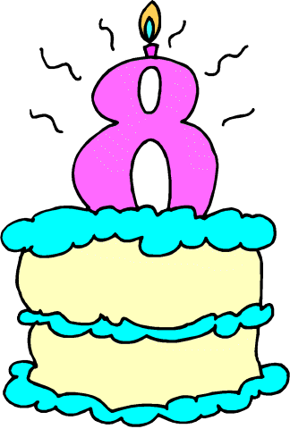  eightyashgb  …………………….. | 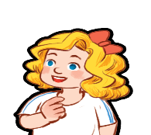  wgbsgmaryngs  ………………….. |   wahylpgfive  …………………

Task 5. Choose the correct answer to complete the dialogue.
Bill: (0)Hi. I’m Bill. What’s (1) _____________name?
Nam: Hello, Bill. My (2)__________ Nam.
Bill: How (3)______ are you ?
Nam: I’m(4)____________ years old.
- a . fine b. nice c. Hi
- a . our b. your c. you
- a . name’s b. name c. names
- a . much b. old c. many
- a . nice b. fine c. nine
Task 6 . Rearrange the words to make the correct sentences.
1. name / What’s / your /?
………………………………………………………………………………………………
2. is / Mary / name / My /.
………………………………………………………………………………………………
3. old / are / How / you /?
………………………………………………………………………………………………
4. ten / old / I’m / years /.
………………………………………………………………………………………………

