UNIT 10: COLOURS
A.PHONICS
football volleyball
B. VOCABULARY
football  play chess  play table tennis  play basketball  play badminton  do word puzzles | : bóng đá  : chơi cờ  : chơi bóng bàn  : chơi bóng rổ  : chơi cầu lông | play hide- and -seek  blind man’s bluff  play volleyball  break time  skipping  chat | : chơi trốn tìm  : bịt mắt bắt dê  : chơi bóng chuyền  : giờ ra chơi  : nhảy dây  : nói chuyện phiếm

C.SENTENCE PATTERNS
1.Nói về hoạt động vào thời gian giải lao.
-I play chess at break time.
2. Hỏi và trả lời xem bạn làm gì vào thời gian giải lao.
-What do you do at break time?( Bạn làm gì vào giờ giải lao? )
->I play badminton. ( Tôi chơi đánh cầu lông.)
D. EXERCISES
Task 1. Fill in the blank with the correct letter.
0.skipping | 1. b__eak time | 2.che__s
3. s__ating | 4.foo__ball | 5.bask__tball
6. __olleyball | 7. table te__nis | 8.ba__minton
Task 2. Look and circle the correct answer.

1.  football / chess | 2.  football / volleyball | 3.  badminton/basketball
4  .  skating / skipping | 5.  football / volleyball | 6.  skipping / chess
Task 3 .Let’s write
0.We play hide - and- seek.  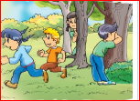 | 1.I …………….at break time.  
2. They play ………………..  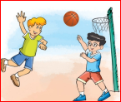 | 3. I like………………….  
4. We play ………………...  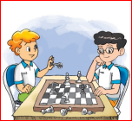 | 5. They play……………….  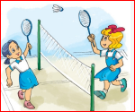
Task 4. Read and match.
1. What do you do at break time? |  | a. It’s white.
2. What color is it? |  | b. No, I don’t.
3. What coluor are they? |  | c. I play table tennis.
4. Do you have a pencil case? |  | d. It’s a school bag.
5. What’s this? |  | e. They are green.
Task 5. Read and complete.
1. I play table tennis…………………………break time.
2. ………………….do you do at break time? I…………………football.
3. I…………………….word puzzles.
4. What …………………..Mai do at break time? She …………………..chess.
5. It ………………break time. I’m ………………the school yard.
6. I ............... volleyball with my friends at break time.
7. Let’s……………………………to the art room! Ok, Let’s go.
8. What …………………….are the pencils? They …………..blue.
9. What…………………they do at break time? They play football.
10. …………………….is your ruler? It’s green.

