UNIT 14: MY BEDROOM
- PHONICS
room door

B. VOCABULARY:
desk : cái bàn học sinh  bed : cái giường ngủ  door : cửa ra vào  window : cửa sổ | old : cũ  new : mới  big : to, lớn  small : nhỏ, bé
C.SENTENCE PATTERNS:
1. Nói về đồ vật ( Số ít và số nhiều)
- There’s a desk in the room.( Có 1 cái bàn ở trong phòng.)
-There are two windows in the room.(Có 2 cái cửa sổ ở trong phòng.)
2. Mô tả về đồ vật ( Số ít và số nhiều)
-The door is big. ( Cái cửa thì to.)
-The chairs are old. ( Những cái ghế thì cũ.)
D. EXERCISES
Task 1. Fill in the blank with the correct letter.
0.door |  | 1.b__d
2. de__k | 3.sm__ll | 4.bi__
Task 2. Fill in the blank with the correct word.
0.new | 1…………….. | 2……………..
3…………….. | 4…………….. | 5……………..

Task 3.Let’s write
1. My school bag is new.   | 2. There is a big ………….. in the bedroom.  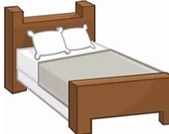
3. There are three …………….. in the living room.  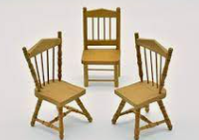 | 4. There is a ……………. in this room. It’s new.  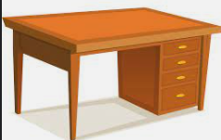
5. There is a………………….on the table.  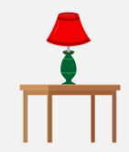 | 6. There are two…………………  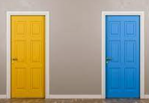
Task 4. Matching
1. This | a. book on the table.
2. My school bag is | b. are two chairs in the room.
3. There is a | c. is my house.
4. That is | d. new.
5. There | e. my bedroom.
Task 5. Rearrange the words to make the correct sentences.
1. is/ my/ bedroom/ This/./
……………………………………………………………………………………………..
2. There/ lamp/ in/ the/ a/ is/ room/./
……………………………………………………………………………………………..
3. two/ are/ windows/ There/ the/ in/ living room/./
……………………………………………………………………………………………..
4. bedroom/ is/very/ My/ beautiful/./
……………………………………………………………………………………………..
5. lamp/ on/ There/ is/ table/a / the/./
……………………………………………………………………………………………..
6. small/ kitchen/ is/ The/./
……………………………………………………………………………………………..

