UNIT 16: MY PETS

*VOCABULARY:
Pets: những con thú cưng ………...…… ……………… …………….… …………….
dogs: những con chó ………...…… ……………… …………….… …………….
cats: : những con mèo ………...…… ……………… …………….… …………….
fish: : những con cá ………...…… ……………… …………….… …………….
goldfish: những con cá vàng………...…… ……………… …………….… …………….
birds: những con chim ………...…… ……………… …………….… …………….
parrots: những con vẹt ………...…… ……………… …………….… …………….
rabbits: những con thỏ ………...…… ……………… …………….… …………….
*.SENTENCE PATTERNS:
1. Hỏi xem bạn có thú cưng nào không.
- Do you have any rabbits? ( Bạn có con thỏ nào không?)
->Yes, I do./ No, I don’t.
2. Hỏi xem ai đó có bao nhiêu con thú cưng.
-How many dogs do you have? ( Bạn có bao nhiêu con chó?)
-> I have some/ many. ( Tôi có một vài/ nhiều)
D. EXERCISES
Task 1. Choose the odd one out
1. a. pets b. cat c. dog d. rabbit
2. a. chicken b. food c. fish d. meat
3. a. milk b. juice c. drink d. orange juice
4. a. house b. bedroom c. kitchen d. dining room
5. a. old b. new c. big d. door
6. a. window b. chair c. room d. table
7. a. family b. father c. sister d. mother
8. a. worker b. doctor c. brother d. farmer
9. a. nurse b. singer c. job d. cook
10. a. you b. your c. my d. her
11. a. I b. she c. he d. my
Task 2.Fill in the blank with the correct word.
1.parrots | 2……………….. | 3………………….
4. ……………….. | 5. ………………….. | 6. …………………….

Task 3.Let’s write
1. I have four parrots.  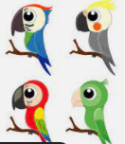 | 2. Mary has two ………………………  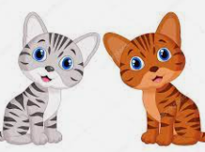
3. Do you have any …………………?  Yes, I do.  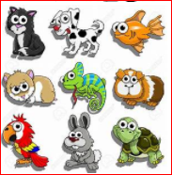 | 4. Do you have any cats? - No, I don’t.  I have four ………………..  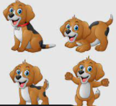
5. How many ……………..do you have?  I have some.   | 6. How many ……………. do you have?  I have many.  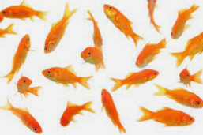
Task 4. Read and tick Yes (Y) or No (N).
I’m Hung. I and my friends love pets very much. They have many pets. Nam has two dogs. Mary has three cats and one rabbit. Linh doesn’t have parrots, but she has five birds. Daisy and her brother have eight goldfish. I have four dogs and five goldfish.
 |  | Yes | No
0. | Hung and his friends love pets very much.
1 | Hung and his friends have some pets.
2 | Mary has three cats and one rabbit.
3 | Linh has three parrots and five birds.
4 | Hung has four dogs and five goldfish.
Task 5. Reorder the words to make sentence
1. Do / pets?/ like / you / ->…………………………………………………………….
2. you / parrots? / Do / have / any / ->……………………………………………………….
3. have?/ dogs / many / How / you / do / ->……………………………………………………
4.are / goldfish / These / my ->………………………………….…………………………
5. has / parrots / three / five birds./ and / She / ->……………………………………………
6. many / I / my / have / pets / house. / in / ->………..………………………………………
7. have / a / cats. / two / and / They / dog / ->………..………………………………………
8. would / eat? / to/ What / you / like / ->………..………………………………………
9. would / drink? / to/ like /What / you / ->………..………………………………………

