UNIT 4: OUR BODIES
A.PHONICS
hair ears
B. VOCABULARY
face : mặt  ear : tai  eye : mắt  mouth : miệng  nose : mũi | hair : tóc  hand : tay  open : mở  touch : chạm, sờ
C. SENTENCE PATTERNS
1. Hỏi xem đó là cái gì
What’s this?->It’s an eye
What’s that?->It’s a face
2. Đưa ra lời chỉ dẫn
- Touch your hair!
- Open your mouth!
D. EXERCISES
Task 1. Look and tick or cross
1. 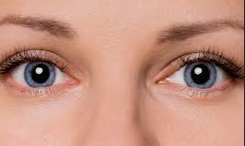  eyes | 2. 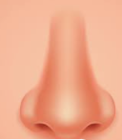  face
3 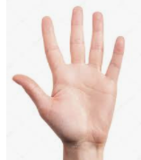  hand | 4. 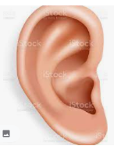  ear
5. 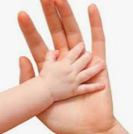  touch | - 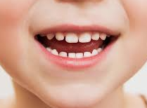  nose
- 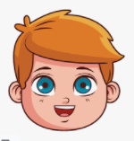  mouth | - 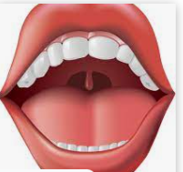  open
Task 2. Look read and circle.
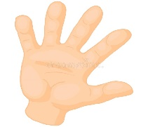1.a. hand  b. head | 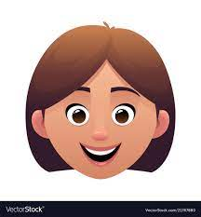2.a. face  b. hand | 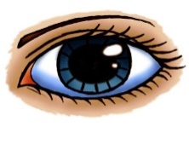3.a. an eye  b. an ear
Task 3. Odd one out.

1. A. game B. hand C. face D. ear
2. A. hair B. mouth C. nose D. hand
3. A. open B. touch C. play D. this
4. A. your B. my C. I D. her
5. A. hello B. hi C. good morning D. touch
Task 4. Let’s write
0.Touch your ears.  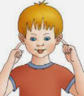 | 1. Touch your ……………..  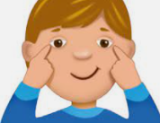
2. Touch your ………………   | 3.Touch your ……………..  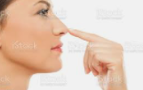
4.Open your ………………  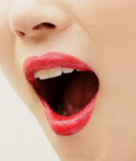 | 5.Touch your ……………..
Task 5 . Read and match.
2.your nose
0.your mouth
Touch
3.your eyes
1.your ear

4.your face
Open

Task 6 . Rearrange the words to make the correct sentences.
1. is/ What / this /?
………………………………………………………………………………………..
2. mouth / your / Open /.
………………………………………………………………………………………..
3. your / ears / Touch /.
………………………………………………………………………………………..
4. eyes / your / Open /.
………………………………………………………………………………………..
5. face / It / a / is /.
………………………………………………………………………………………..
6. hair / your / Touch /………………………………………………………………..

