UNIT 5: MY HOBBIES
A.PHONICS
painting running
B. VOCABULARY
hobby : sở thích  cooking : nấu ăn  dancing : nhảy, múa  drawing : vẽ  painting : vẽ, tô vẽ | running : chạy  singing : hát  swimming : bơi  walking : đi bộ
C. SENTENCE PATTERNS
1. Hỏi về sở thích
- What’s your hobby? ( Sở thích của bạn là gì? )
–> It’s singing. (Là hát.)
-> I like dancing. (Tôi thích nhảy.)

D.EXERCISES
Task 1. Look and circle the correct answer.
  Singing / dancing | Drawing / dancing | Singing / Running
Painting / Drawing | Singing / walking | Singing / Cooking
Walking / dancing | Singing / swimming | hobbies / dancing
Task 2. Fill in the missing letter.

0.Cooking
3.Si_ging
2.Draw_ng
1.Dan_ing
4.Wa_king
6. R_nning
7.Pain_ing

7pain_ing
6.r_nning
5.Swim__ing
4. Wa_king
Task 3. Choose the best answer.
1. _____is your hobby? It’s singing.
A. Where B. How old C. What D. How
2. My hobby is _____.
A. to cook B. cook C. cooking D. cooks
3. I like______.
A. run B. runing C. running D. runs
4. What’s your hobby?- ______swimming.
A. he B. It C. I D. It’s
5. What’s _____ hobby? My hobby is walking.
A. him B. her C. your D. my
Task 4. Read and number.
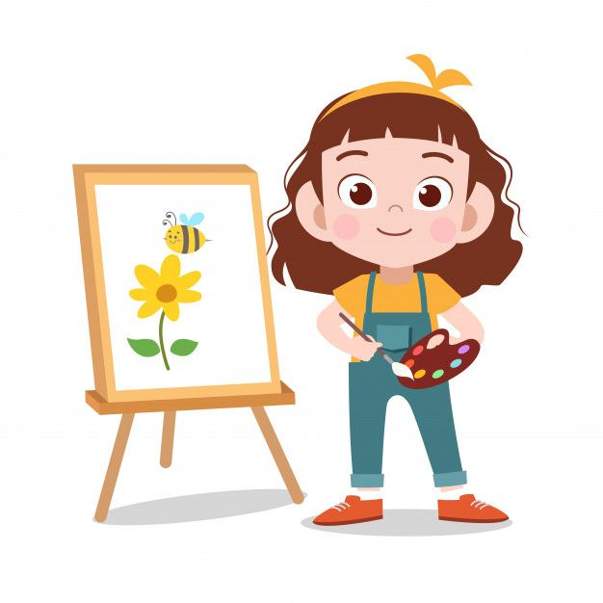


1. It’s cooking.
2. My hobby is singing.
3. I like painting.
4. He likes walking.
5. She likes running.
6. I like swimming.



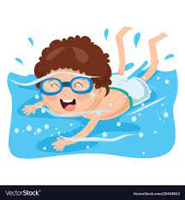

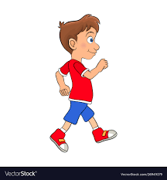
Task 5 Read and write.
1. What’s your…………..? I like singing.
2. ………………..is your hobby? It’s dancing.
3. What’s ……………………..hobby? Her hobby is walking.
4. My ………………………is cooking in the evening.
5. She likes ………….. in the afternoon.
6. I………………..cooking.

