UNIT 8: MY SCHOOL THINGS
A.PHONICS
book eraser
B. VOCABULARY
pen  pencil  book  school bag | : bút  : bút chì  : sách  : cặp sách | ruler  pencil case  eraser = rubber  school things | : thước kẻ  : hộp bút  : tẩy  : đồ dùng học tập

C.SENTENCE PATTERNS
1.Giới thiệu mình có thứ gì.
-I have a school bag. (Tôi có một cái cặp.)
2. Hỏi xem ai đó có đồ gì hay không
-Do you have an eraser? ( Bạn có một cục tẩy phải không?)
->Yes, I do. / No, I don’t.
D. EXERCISES
Task 1 Look, read and circle.
4
3
2
1
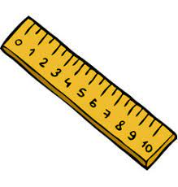


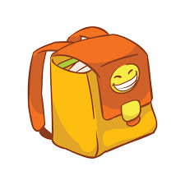
ruler/ pen
eraser/ notebook

hat /school bag

book/ pencil

Task 2. Unscramble the letters.

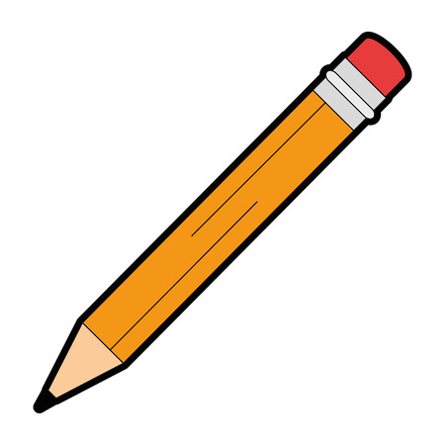

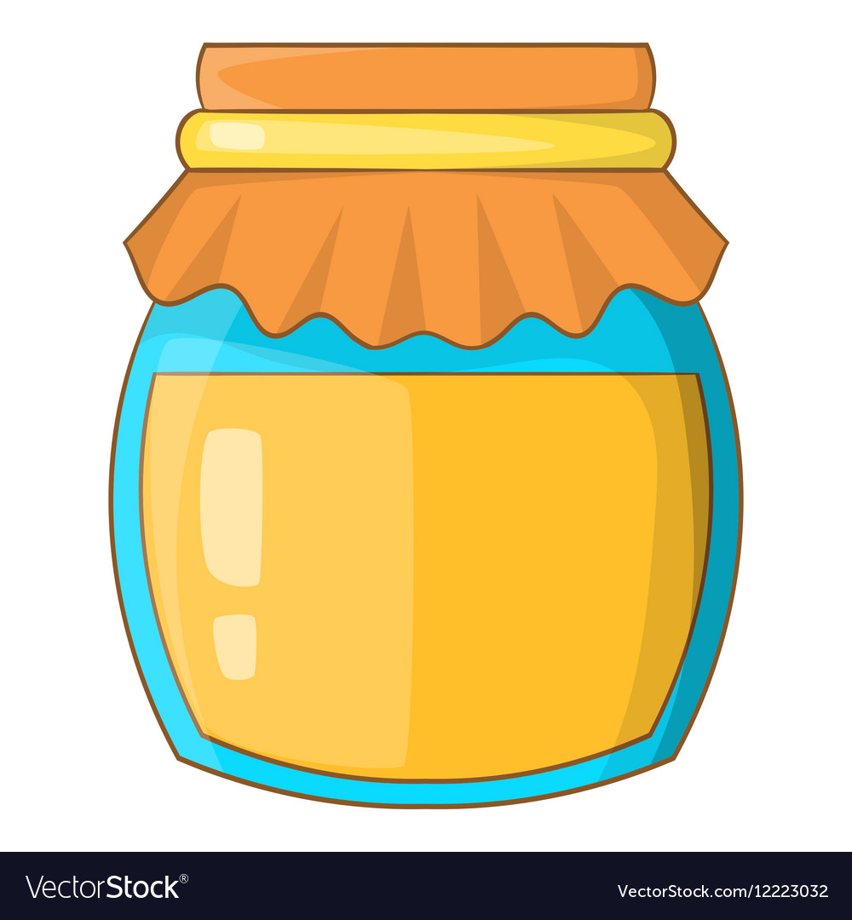
e p c
l n i
s r e
a r e
o b k
o
n e p

…………………………

…………………………

………………………

…………………………

Task 3. Find the correct words and write.
1.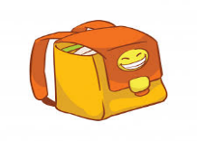  eschoolbagmh  ………………………… | 2.   wavhnotebook  ………………………… | 3.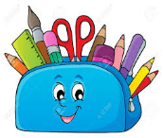  pencilcaseiolh  …………………………
Task 4. Read and complete the words in the box.
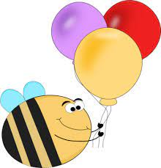
have
I
eraser

notebook

Lucy: Hi. (1)…………you(2)…………a(3)……..….?
Tom: Yes, (4)……………………do.
Lucy: Do you have an(5)………………………?
Tom: No, I don’t. But I have(6)……….……..ruler.
a
Do

Task 5. Read and number the correct pictures.
1. I have a notebook.  2. I have an eraser.  3. She has a pen.  4. He has a ruler.  5. Lan has a school bag.  6. I have some school things.  7. I have a pencil case.  8. I have a book.  9. She has a pencil. | A | B | C
 | D | E | F
 | G | H | I
Task 6. Read and complete.
1. ……………………you have a pen? Yes, I…………..
2. I have a ruler. …………………a pencil.
3. This …………..…….a book.
4. Do you have………………eraser? -………., I do.
5. Look ……….……..my school things.
6. I …………… a notebook and a pencil.
7. I have a ruler but I …………………have a pencil case.
8. Do ………….. have a school bag, Mai? No, I…………………..………

