UNIT 9: COLOURS
A.PHONICS
blue brown
B. VOCABULARY
Colour = color  black  blue  brown  yellow | : màu sắc  : màu đen  : màu xanh dương  : màu nâu  : màu vàng | green  orange  red  white | : xanh lá cây  : màu cam  : màu đỏ  : màu trắng

C.SENTENCE PATTERNS
1. Hỏi màu sắc của đồ vật ( số ít)
- What colour is it? ( Nó có màu gì? )
-> It’s red. ( nó màu đỏ)
2. Hỏi màu sắc của đồ vật (số nhiều)
- What colour are they? ( Chúng có màu gì? )
-> They’re yellow. ( Chúng màu vàng)
* It’s = it is * They’re = they are
D. EXERCISES
Task 1 Unscramble the letters.
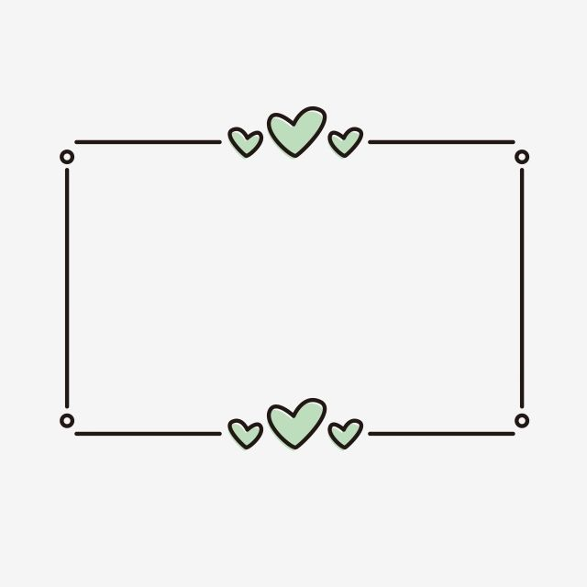
b o r w n

e r d

u b l e
1
2

4

3

e l o l w y

…………

…………

…………

…………

Task 2 Read and number.
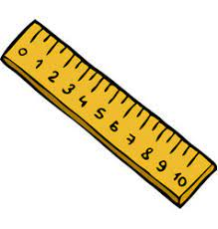

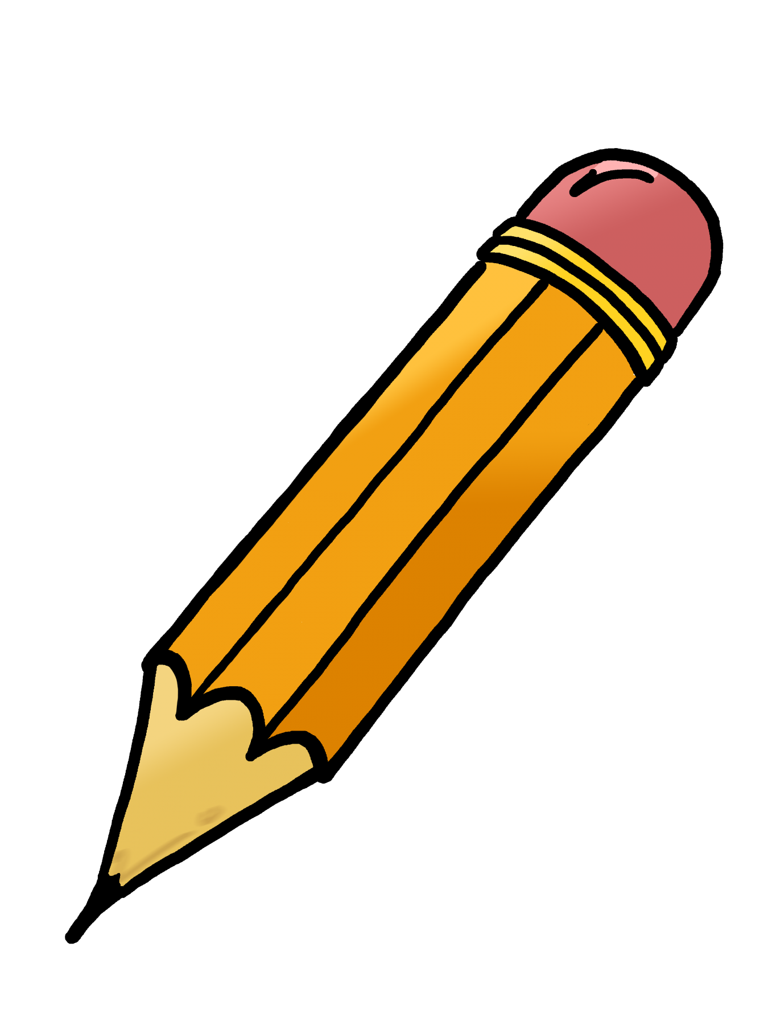
1. The book is green.
2. The pencil is orange.
3. The school bag is black.
4. The ruler is yellow.
5. The pencil case is blue.
6. The eraser is red and blue.


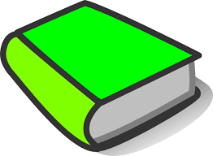

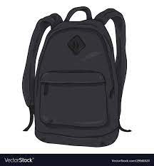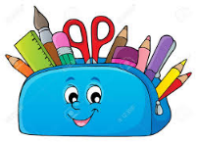

Task 3 Circle the odd one out.
1. A. colour B. red C. yellow D. blue
2. A. eraser B. ruler C. pen D. school things
3. A. pencils B. books C. pens D. black
4. A. blue B. they C. white D. green
5. A. they B. it C. blue D. I
Task 4 Choose the best answer.
1. What colour is it? ……………….is red.
A. She B. It C. They D. He
2. What colour are ……………? They are blue.
A. we B. you C. this D. they
3. What colour ………………the rulers? They are orange.
A. aren’t B. are C. is D. am
4. ……………you have pencils?
A. Is B. Are C.Does D. Do
5. I…………. my school things very much.
A. open B. like C. have D. look
Task 5. Read and answer the questions.
Hi, my name is Bill. I have many school things. I have five pens. They are blue. This is my school bag. It’s yellow. That’s my English book. It is black and white. I also have two rulers. They’re orange. I love my school things very much.
1. What’s his name?
……………………………………………………………………………………………
2. Does Bill have five pens?
……………………………………………………………………………………………
3. What colour are the pens?
……………………………………………………………………………………………
4. What colour is the school bag?
……………………………………………………………………………………………
5. What colour are the rulers?
……………………………………………………………………………………………

