 | KIM ĐỒNG PRIMARY SCHOOL |  | THE ENGLISH TEST
 | NAME: ……………………………... |  | School year: 2022-2023
 | CLASS: 5…………………………. |  | Time: 35 minutes
Mark |  | Comment
I. READING
Task 1. Look and write the correct words. There is one example( Đọc và viết từ đúng). 2pts
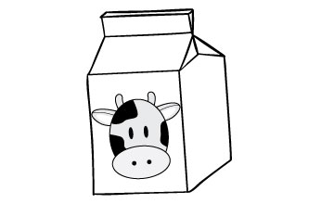 | 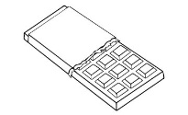 | 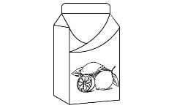
milk | chocolate | lemonade
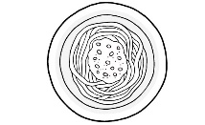 | 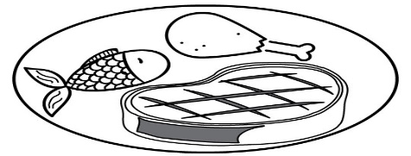 | 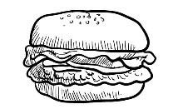
noodles | meat | sandwich

Example: There are long, made from rice or wheat. | noodles
1. sweet and brown candy __ | ____________
2. meat (or cheese) and vegetables between two pieces of bread | ____________
3. white drink from cows | ____________
4. drink made from lemons | ____________
5. food from pigs or cows | ____________
Task 2. Read and tick  True or False. There is one example (0).( Đọc và tick vào True và False). 2pts
To stay fit and healthy, you shouldn’t eat too many fatty foods such as fried potatoes, fried meat and sausages. It is not good for you to eat too much butter and chocolate. You need to eat some fish, chicken or eggs for meals. Fruits and vegetables are important foods. They give you vitamins and minerals. Every day, you should have fruit juice for breakfast, eat a lot of vegetables at meal times. You also need to drink a lot of milk and water.
 | True | False
0. To keep good health, you can eat a lot of fatty foods such as fried potatoes, meat and sausages. | 
1. Eating too much butter and chocholate is not good for you.
2. You shouldn’t have some fish, chicken or eggs for your meals.
3. Fruits and vegetables give you vitamins and minerals.
4. You need to have some fruits for breakfast and eat some vegetables for meals.
5. You need to drink a lot of milk and water every day.
Task 3. Read and fill each gap with one word from the box. Write the word next to the number. There is one word that you do not need. There is one example (0) ( Đọc và điền từ vào chỗ trống) 2pts
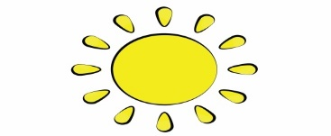 | 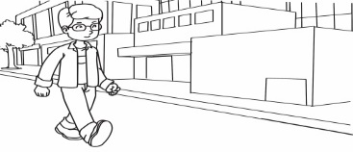 | 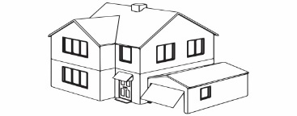 | 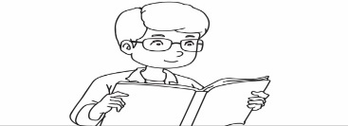
sunny | walk | house | reading
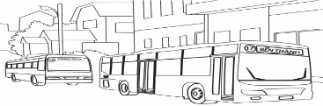 | 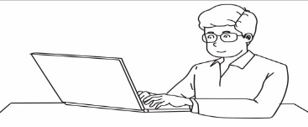 | 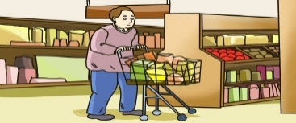
buses | writer | supermarket
Ben lives in a (0) house in a busy area. There are a lot of cars, (1) __________ and lorries in the street. Ben often goes shopping at a big and crowded (2) __________ opposite his house. There’s a bookshop on the corner of the street. Ben can (3) __________ there in ten minutes. He likes (4) __________ very much, so he goes to the bookshop every weekend. He would like to be a (5) __________ in the future. Ben likes the neighbourhood because he loves to see people and the busy life in the city.
II. WRITING
Task 1. Order the words. There is one example.( Sắp xếp thành câu đúng). 2pts
Example: a / doctor / like / to / he / future / in / would / the / be
He would like to be a doctor in the future.
1. you / do / to / you / what / like / would / grow / up / when
___________________________________________________________________?
2. you / to / where / work / would / like
____________________________________________________________________?
3. is / your / dream / job / Susan / what
__________________________________________________________ , ____________?
4. old / look / she / people / to / would / like / after
_______________________________________________________________________
5. job / Maths / teaching / dream / is / my_______________________________________.
Task 2. Write a short letter to your friend about your future life. There is one example (0). (Viết 1 lá thư ngắn cho bạn).2pts
To: John Brown,
Hi John,
0. Let me tell you about my future life.
1. In the future, I’d like to be a/an____________________________________________.
2. I’d like to _____________________________________________________________.
3. I’d like to work in/at _____________________________________________________.
4. I’d like to live __________________________________________________________.
5. I’d like to live in __________________________ because life in _________________
_________________________________________________________________________.
See you soon.
Love,
___________

TRƯỜNG TIỂU HỌC KIM ĐỒNG

ĐÁP ÁN BÀI KIỂM TRA CUỐI HỌC KÌ I-KHỐI 5
Năm học 2022-2023
KEY

I. READING
Task 1. Look and write the correct words. There is one example.
Key: 1. chocolate 2. sandwich 3. milk 4. lemonade 5. meat
Task 2. Read and tick True or False. There is one example (0).
Key: 1. True 2. False 3. True 4. False 5. True
Task 3. Read and fill each gap with one word from the box. Write the word next to the number. There is one word that you do not need. There is one example (0).
Key: 1. buses 2. supermarket 3. walk 4. reading 5. writer
II. WRITING
Task 1. Order the words. There is one example.
Key:
1. What would you like to do when you grow up?
2. Where would you like to work?
3. What is your dream job, Susan?
4. She would like to look after old people.
5. My dream job is teaching Maths.
Task 2. Write a short letter to your friend about your future life. There is one example (0).
Student’s answers vary with correct grammar.

